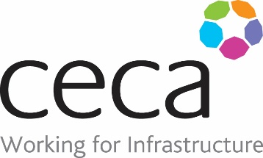

“GOING THE EXTRA MILE” AWARD 2021 – Entry Form

Project Name……....………………………………………………………………….……………………….........

Project Completion Date…...……………………………………………………………………………………….

Contractor Company Name…..…………………………………………………………………………………….

Client Name………………………………………………………………………..……………………………………….

Contact Name (Contractor)………….………………………………………………………………………………

Contact Address…………………………………………………………………………………………………………..

……………………………………………………………………………………………………………………………………..

Contact Signature………………………………………………………………………………………………………..

Date of Submission……………………………………………………………………………………………………..
GUIDELINES FOR SUBMISSION / (Up to 1000 Words)

CECA (NE) members do more than just “construct”. Every member gives an added value by going the extra mile.

Your entry should consist of not more than 1000 words with the aid of photographs, if appropriate, the following headings may assist with your entry. Your entry is not limited to these headings – it is up to you to decide the format of the entry.

- Background information describing the scheme
- An overview of the activities you undertook – What ? Why ? How ?
- What was the outcome of the activity(s) ?
- What is the benefit of the activity(s) ?
- What is the future legacy of the activity(s) ?
- How did the activity benefit Civil Engineering and the Region ?
- To be eligible the scheme must have been completed between 1st January 2019 - 31st December 2020.

- Entries must be received by 30th September 2021

- Entries must be received by 31 May 2019

