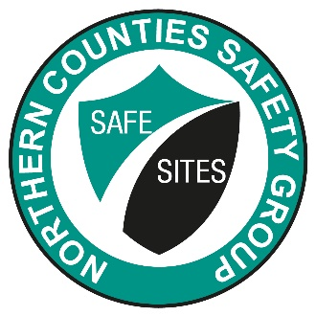
SPONSORED BY
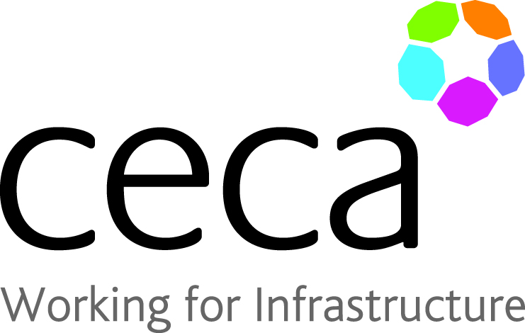

HEALTH & SAFETY COMPANY OF THE YEAR 2021 – Entry Form

Contractor Company Name…..…………………………………………………………………………………….

Contact Name………………………………………………………………………………………………………………

Contact Address…………………………………………………………………………………………………………..

……………………………………………………………………………………………………………………………………..

Contact Signature………………………………………………………………………………………………………..

Date of Submission……………………………………………………………………………………………………..
GUIDELINES FOR SUBMISSION / (Up to 1000 Words)

- Your entry should outline the specific reasons why your Company should receive the 2021 CECA (NE) award in this category.
- Your statement should indicate your targets and achievements (numerical) and include, but not be limited to the range of Health and Safety activities, initiatives and programmes undertaken throughout 2020.

- Entries must be received by 30th September 2021

