Have your say on new designs for A358 Taunton to Southfields upgrade

National Highways wants your views on its updated designs for the upgrade of the A358 in Somerset.

The planned upgrade of the A358, a key route linking the south west and London and south east, will see a single lane stretch of carriageway between the M5 at Taunton and the Southfields roundabout upgraded to dual carriageway.

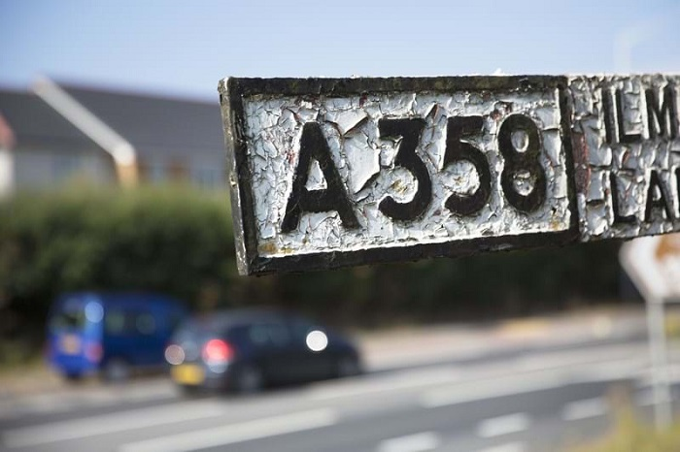
Caption: Have your say on the new designs for A358 Taunton to Southfields upgrade from the 12 October

Katherine Liddington, Senior Project Manager for the A358 scheme, said:
“We plan to build approximately 8.5 miles of new dual carriageway, which will considerably improve road safety, reduce traffic congestion and improve connectivity for road users and local communities, while unlocking economic growth in Somerset and beyond.

“Since announcing our preferred route for the project in 2019 we have been working to refine the preliminary design for the new road. We’ve made some improvements to our proposals, which will improve access safety to local roads and reduce the impact on communities, the environment, and the local landscape.

“As part of the planning process, we would like to hear your thoughts on our proposed design. This will help refine our preliminary design before we submit our planning application in 2022.”

In delivering the scheme, we’re aiming to:

- improve the capacity of the road to reduce delays and queues that occur during peak hours and at key times of the year i.e. the height of summer.
- support economic growth, facilitating growth in jobs and housing by providing a free-flowing and reliable connection between the south east and the south west
- make the road safer, by providing additional capacity and reducing driver stress. We’ll also improve routes for pedestrians, cyclists, horse riders in the area
- protect the environment and look for opportunities to improve it, minimising any unnecessary impact of the scheme on the surrounding natural and historic environment and landscape
- work with local communities to reduce the impact of the road, and look for ways to improve local people’s quality of life
- make journey times more reliable and resilient; by providing more capacity it will become easier to manage traffic when incidents occur

Consultation runs from 12 October to 22 November 2021 with feedback helping National Highways develop its planning application for a Development Consent Order (DCO) to be submitted next year.

A DCO is required for all nationally significant infrastructure projects and will allow for the Planning Inspectorate to make a recommendation to the Secretary of State, who will decide on whether development consent should be granted for the proposed scheme.

All plans will be available on a dedicated consultation website, that can be accessed via www.highwaysengland.co.uk/a358-taunton-to-southfields from 10:00 on the 12 October 2021 where you’ll also be able to ask our project team any questions you may have via a web chat function.

National Highways are holding three public consultation events in line with government guidance:
- Tuesday 19 October 2021, 2pm – 8pm: Taunton Racecourse, Orchard Portman, Taunton, TA3 7BL,
- Saturday 23 October 2021, 11am – 6pm: Monks Yard (Conference Room), Horton Cross Farm, Horton Cross, Ilminster, Somerset, TA19 9PT,
- Wednesday 3 November 2021, 11am – 6pm, Holiday Inn Taunton, Deane Gate Avenue, Taunton, Somerset, TA1 2UA,

There will also be several themed webinars, for more information on these, visit: http://www.highwaysengland.co.uk/a358-taunton-to-southfields

If you do not have access to the internet, you can request a free copy of our consultation booklet, feedback questionnaire and non-technical summary of the Preliminary Environmental Information Report’ by calling 0300 123 5000 or emailing A358TauntontoSouthfields@highwaysengland.co.uk

