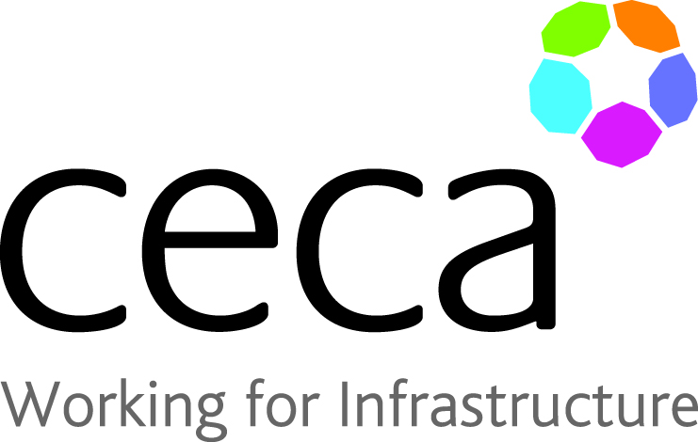

PROJECT OF THE YEAR 2022 – Entry Form

Category: £1M – £5M

Project Name……....………………………………………………………………….……………………….........

Project Completion Date…...……………………………………………………………………………………….

Contractor Company Name…..…………………………………………………………………………………….

Client Name………………………………………………………………………..……………………………………….

Contact Name (Contractor)………….………………………………………………………………………………

Contact Address…………………………………………………………………………………………………………..

……………………………………………………………………………………………………………………………………..

Contact Signature………………………………………………………………………………………………………..

Date of Submission……………………………………………………………………………………………………..
GUIDELINES FOR SUBMISSION / (Up to 1000 Words)

- Description of the scheme
- Performance against budget and programme
- Technologies used (if appropriate)
- How did your company add value to the scheme?
- What innovative processes and techniques did you use?
- What challenges did you overcome and how?
- Please feel free to submit photographs, drawings and videos of the scheme
- To be eligible the project must have been completed between 1st January 2020 – 31st December 2021.

- Entries must be received by 30th September 2022

