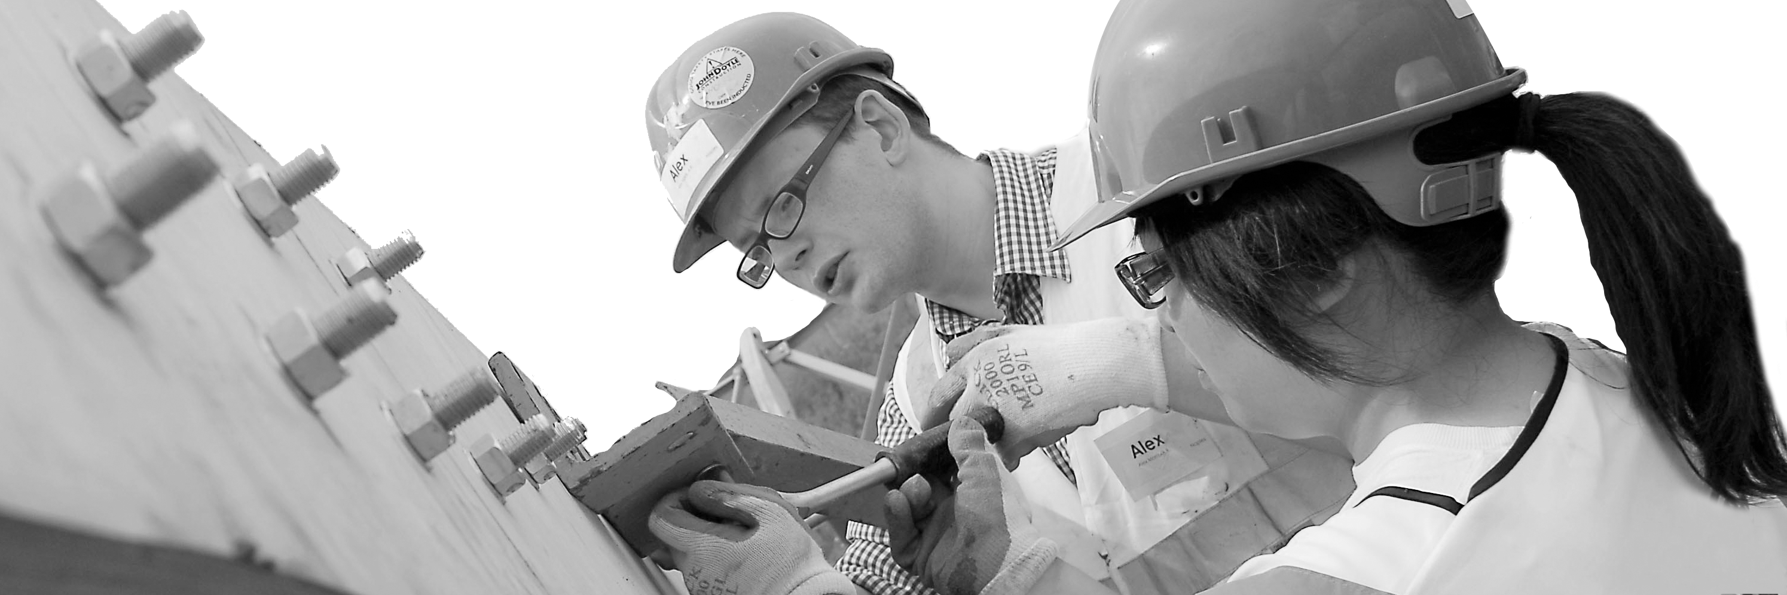
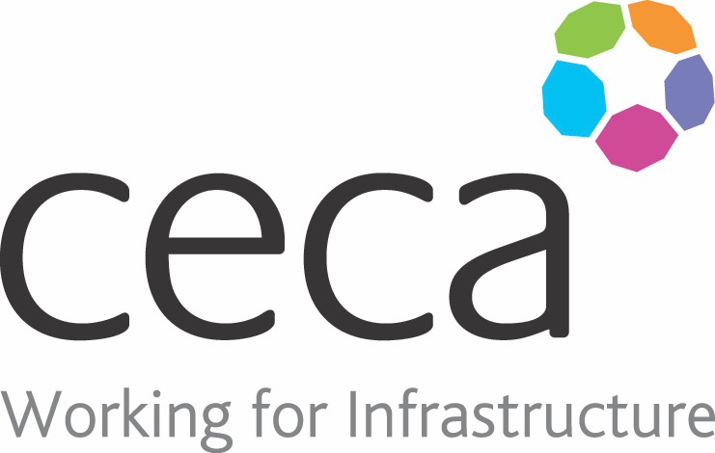
CECA Midlands E Learning

ABRASIVE WHEELS SAFETY AWARENESS
Abrasive wheels’ is a term used to cover equipment such as angle or bench-mounted grinders which are popular power tools used for grinding, de-burring, fettling, polishing, sanding and buffing.
Various types of abrasive products can be used and the equipment includes powered wheels, cylinders or belts made with abrasive materials. They are very fast moving and therefore, unless they are fitted and used correctly, they can be very dangerous and can cause serious injury. Health & safety legislation requires that training is given to anyone using such equipment.
The course looks at the different types of equipment and abrasive wheels and covers subjects including choosing the correct equipment, the safety aspects when using it and maintaining the abrasive wheels. It also includes the legal responsibilities when using them.
The course deals with safety and it should not replace practical training, although it is useful as a refresher. It is not designed to teach someone how to fit and use abrasive wheels.

Learning objectives:
- Abrasive Wheels
- Wheel Types
- Choosing the Correct Wheel
- Using and Maintaining the Equipment

Assessment:
This training programme concludes with a 20 question multiple choice test with printable certificate. In addition, brief in-course questionnaires guide the user through the sections of the training, and are designed to reinforce learning and ensure maximum user engagement throughout.
Cost: Registration fee £20 +VAT for full and associate CECA Midlands members
Award: E learning certificate

Company name: |  | Company contact name:
Company email: |  | Contact tel:
Delegate name: |  | Job title:
Delegate email: |  | Delegate tel:
Accounts Name: |  | Accounts email:

Abrasive Wheels Safety Awareness
Booking Form – please complete and return to admin@cecamidlands.co.uk one per delegate.

