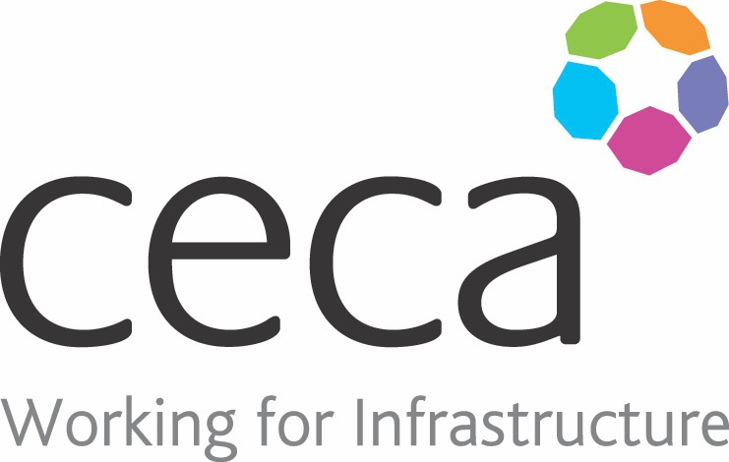
CECA Midlands E Learning

ACCIDENT REPORTING
This Accident Reporting Training programme is designed for everyone to use. It explains what accident reporting is, why it’s important and what could be included in a report.
It ensures that everyone in your workplace knows how to complete a clear and concise accident report if they’re involved in an accident or incident at work.
It also explains how good accident reporting can increase safety at work
Prevention is always better than cure. Take a look at our Risk Assessment Training, it could prevent a number of accidents from happening in your workplace.

Learning objectives:
- The background of accident reporting
- What should be recorded
- Reporting an accident

Assessment:
This training programme concludes with a 20 question multiple choice test with printable certificate. In addition, brief in-course questionnaires guide the user through the sections of the training, and are designed to reinforce learning and ensure maximum user engagement throughout.
Cost: Registration fee £20 +VAT for full and associate CECA Midlands members
Award: E learning certificate

Company name: |  | Company contact name:
Company email: |  | Contact tel:
Delegate name: |  | Job title:
Delegate email: |  | Delegate tel:
Accounts Name: |  | Accounts email:

Accident Reporting
Booking Form – please complete and return to admin@cecamidlands.co.uk one per delegate.

