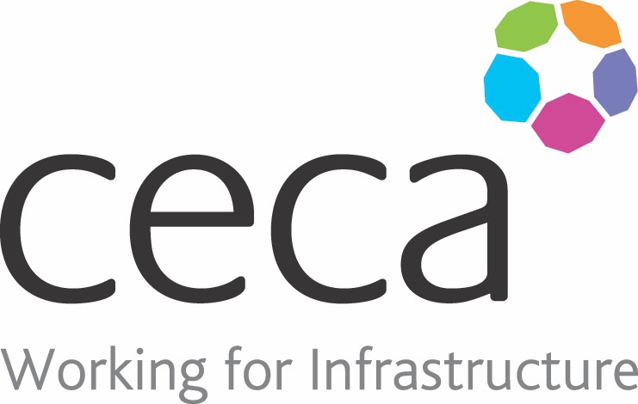
CECA Midlands E Learning

ANTI BRIBERY AWARENESS TRAINING
Bribery is something that happens more often than you may think! In the UK, up to 1 in 4 organisations come under pressure to accept bribes or make illegal payments every year; or lose business to competitors as a result of bribes.
This Anti-Bribery Course course aims to raise awareness. It explains the four offences that can be committed under The Bribery Act. And it looks at the fine line between gifts and bribes – when is it acceptable to give a gift or hospitality? And when might they be seen as a bribe?
It also explains what you should look out for – the signs that suggest that bribery might be taking place. It looks at what you should do if you’ve been given, offered or promised a gift or hospitality and think it might be a bribe, or if you suspect someone else is involved in bribery.
The training course uses a clear, easy-to-understand style, supported by excellent graphics and animation. Scenario-style questions are used throughout the programme as examples to test understanding.

This Anti-Bribery & Corruption course can be used in conjunction with our Anti-Money Laundering course.

Learning overview:
- The types of bribery
- Failing to prevent bribery
- Bribes, gifts and hospitality

Assessment:
This training programme concludes with a 20 question multiple choice test with printable certificate. In addition, brief in-course questionnaires guide the user through the sections of the training, and are designed to reinforce learning and ensure maximum user engagement throughout.
Cost: Registration fee £20 +VAT for full and associate CECA Midlands members
Award: E learning certificate

Company name: |  | Company contact name:
Company email: |  | Contact tel:
Delegate name: |  | Job title:
Delegate email: |  | Delegate tel:
Accounts Name: |  | Accounts email:

Anti Bribery Awareness
Booking Form – please complete and return to admin@cecamidlands.co.uk one per delegate.

