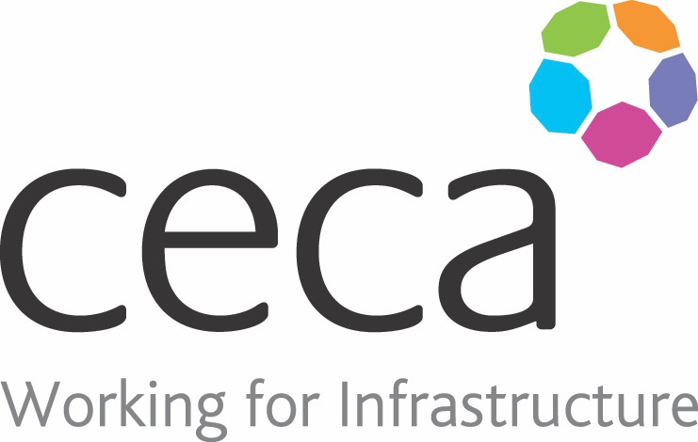
CECA Midlands E Learning

ANTI MONEY LAUNDERING AWARENESS TRAINING
Money Laundering can take many forms and even though you may not realise it, if you are involved, the penalties are harsh.
This course is for everyone who works in any organisation where large amounts of money, property or goods are bought, leased, sold or exchanged, such as the financial services, legal, motor trade, estate agency, gambling or accountancy sectors.
Designed to raise awareness, it explains what money laundering is and the necessity for employees to be on the lookout for anything that might not look or feel right when dealing with transactions.
The course covers the various laws in relation to money laundering crimes and customer verification methods, as well as how to spot suspicious activity.

Learning overview:
- Money Laundering
- Customer Verification
- Suspicious Activity
- Laws, Acts and Policies

Assessment:
This training programme concludes with a 20 question multiple choice test with printable certificate. In addition, brief in-course questionnaires guide the user through the sections of the training, and are designed to reinforce learning and ensure maximum user engagement throughout.
Cost: Registration fee £20 +VAT for full and associate CECA Midlands members
Award: E learning certificate

Company name: |  | Company contact name:
Company email: |  | Contact tel:
Delegate name: |  | Job title:
Delegate email: |  | Delegate tel:
Accounts Name: |  | Accounts email:

Anti Money Laundering Awareness
Booking Form – please complete and return to admin@cecamidlands.co.uk one per delegate.

