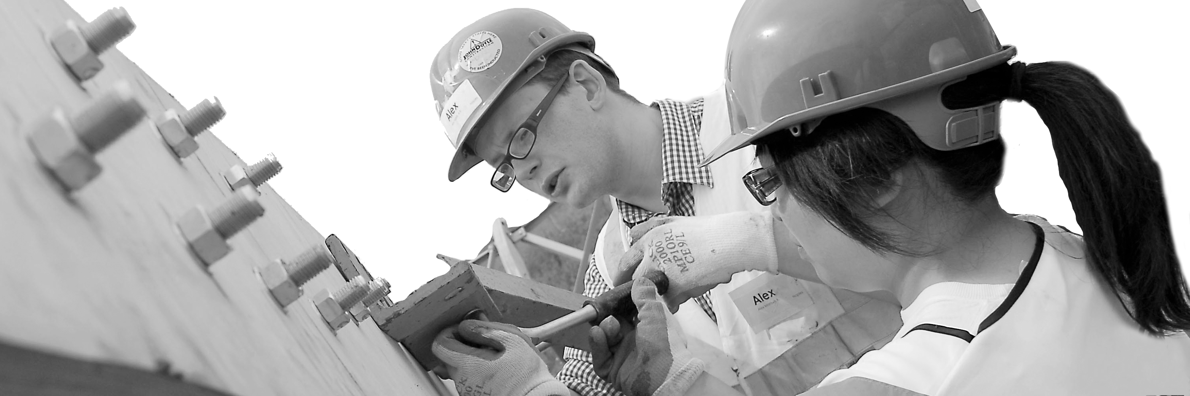
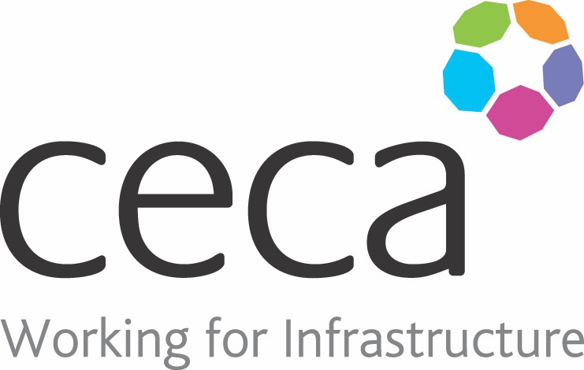
CECA Midlands E Learning

ASBESTOS AWARENESS (UKATA APPROVED)
There are only a few Health & Safety Regulations that require specific training with penalties if it is not done. One of these is Asbestos Awareness which is set out in the Control of Asbestos Regulations 2012 which even sets out what has to be covered.
Anyone who may be likely to be exposed to asbestos at work (i.e. works in a building built prior to 1999) must have the training required by Regulation 10.
According to the HSE Code of Practice, this includes:-
- Site operatives in construction, maintenance, refurbishment or demolition
- Electricians, plumbers and gas fitters and HVAC Engineers
- Painters and decorators
- Plasterers, shop-fitters and roofers
- Telecoms and computer engineers and cabling installers
- Fire, security and burglar alarm engineers
- Architects, surveyors, project managers and other such professions
Every employer must ensure that anyone who is employed by, or labour only sub-contractors under their control, has the training and that it is refreshed annually. Refreshers can be given by various means, not just repeating the initial training.

Learning overview:
- The properties of asbestos and its effects on health, including the increased risk of lung cancer for those exposed to asbestos who smoke;
- The types, uses and likely occurrence of asbestos and asbestos containing materials in buildings and plant;
- The general procedures to be followed to deal with an emergency, e.g. an uncontrolled release of asbestos dust into the workplace;
- How to avoid the risks from asbestos, e.g. for building work, no employee should carry out work which disturbs the fabric of a building unless the employer has confirmed that asbestos containing materials are not present.
Assessment:
There is a 15 question test at the end and to pass, 11 answers must be correct.
Cost: Registration fee £25 +VAT for full and associate CECA Midlands members
* PLEASE NOTE THIS PROGRAMME SHOULD QUALIFY FOR A CITB GRANT
Award: UKATA APPROVED E learning certificate
The UKATA courses that we are offering are sold under license from Asbestos Training Limited who is the UKATA approved Professional Member 111AB and we are not a UKATA Professional Member for this classification of UKATA Asbestos Awareness training.

Company name: |  | Company contact name:
Company email: |  | Contact tel:
Delegate name: |  | Job title:
Delegate email: |  | Delegate tel:
Accounts Name: |  | Accounts email:

ASBESTOS AWARENESS – UKATA APPROVED
Booking Form – please complete and return to admin@cecamidlands.co.uk one per delegate.

