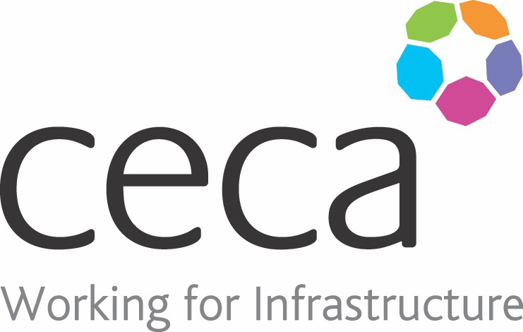
CECA Midlands E Learning

BANKSMAN ESSENTIALS
A Banksman is someone who is responsible for directing movements of large vehicles.
This is usually done by using hand signals (or possibly a radio link) to reduce the risk of accidents occurring, especially when a vehicle is reversing. The Banksman ensures that manoeuvres, particularly during loading and unloading do not put anyone in danger.
​Accidents can always be avoided by taking precautions and this course has detailed explanations of what needs to be done to be safe. It is designed for anyone involved in manoeuvring, loading and unloading vehicles and will give learners knowledge of how to safely guide vehicles, both rigid and articulated, using the HSE's approved code of signals. However, there is nothing like practical application of this knowledge to ensure competency.

Learning overview:
- Roles and duties
- Responsibilities of the employer
- Common hand signals

Assessment:
This training programme concludes with a 20 question multiple choice test with printable certificate. In addition, brief in-course questionnaires guide the user through the sections of the training, and are designed to reinforce learning and ensure maximum user engagement throughout.

Cost: Registration fee £20 + VAT for full and associate CECA Midlands members.
Award: E learning certificate

Company name: |  | Company contact name:
Company email: |  | Contact tel:
Delegate name: |  | Job title:
Delegate email: |  | Delegate tel:
Accounts Name: |  | Accounts email:

Booking Form – please complete and return to admin@cecamidlands.co.uk one per delegate.
BANKSMAN ESSENTIALS

