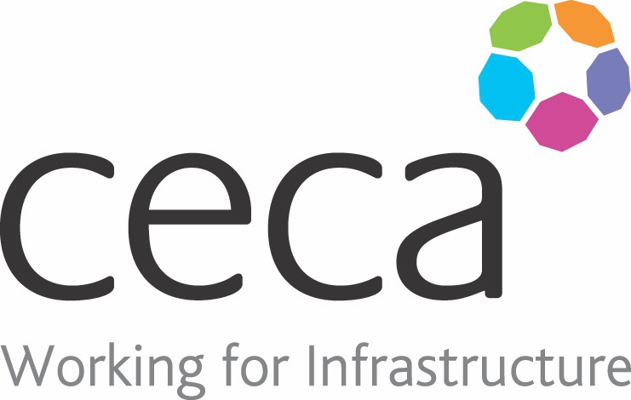
CECA Midlands E Learning

BOMB THREATS & SUSPICIOUS PACKAGES
This training course provides guidance to all employees on general day-to-day good practice regarding security……putting a strong emphasis on vigilance.
We look at search and evacuation procedures and use a step-by-step guide to explain how to deal with a BOMB THREAT.
We look at suspicious packages and the tell-tale signs that packages received in the post may have dangerous contents.
Make your staff more vigilant, equip them with the knowledge needed to deal with a bomb threat or suspicious package and potentially save lives with our Bomb Threats and Suspicious Packages training course.

Learning overview:
- Identifying Risk
- Evacuation and Searches

Assessment:
This training programme concludes with a 20 question multiple choice test with printable certificate. In addition, brief in-course questionnaires guide the user through the sections of the training, and are designed to reinforce learning and ensure maximum user engagement throughout.

Cost: Registration fee £20 + VAT for full and associate CECA Midlands members.
Award: E learning certificate

Company name: |  | Company contact name:
Company email: |  | Contact tel:
Delegate name: |  | Job title:
Delegate email: |  | Delegate tel:
Accounts Name: |  | Accounts email:

Booking Form – please complete and return to admin@cecamidlands.co.uk one per delegate.
BOMB THREATS & SUSPICIOUS PACKAGES

