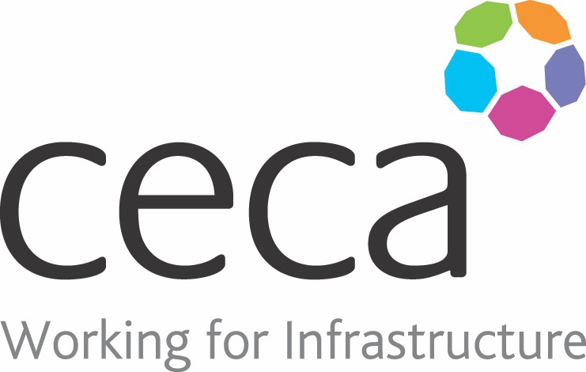
CECA Midlands E Learning

BOBULLYING & HARASSMENT - FOR EMPLOYEES
This online course has been created to help every employee identify, prevent and tackle this negative behaviour with the aim of removing it from the workplace altogether.
It gives this subject the sensitivity it needs whilst providing practical steps that can be used to combat bullying and harassment. This course also focuses on preventing this negative behaviour – employees will learn how to create a positive culture in the workplace.
Make sure you can identify signs of bullying and prevent it from happening in your workplace with our Bullying & Harassment at work training.

Learning overview:
- What are Bullying and Harassment? Differences and Similarities
- What should I do if I am being bullied
- Creating a positive culture in the workplace

Assessment:
This training programme concludes with a 20 question multiple choice test with printable certificate. In addition, brief in-course questionnaires guide the user through the sections of the training, and are designed to reinforce learning and ensure maximum user engagement throughout.

Cost: Registration fee £20 + VAT for full and associate CECA Midlands members.
Award: E learning certificate

Company name: |  | Company contact name:
Company email: |  | Contact tel:
Delegate name: |  | Job title:
Delegate email: |  | Delegate tel:
Accounts Name: |  | Accounts email:

Booking Form – please complete and return to admin@cecamidlands.co.uk one per delegate.
BULLYING & HARASSMENT – FOR EMPLOYEES

