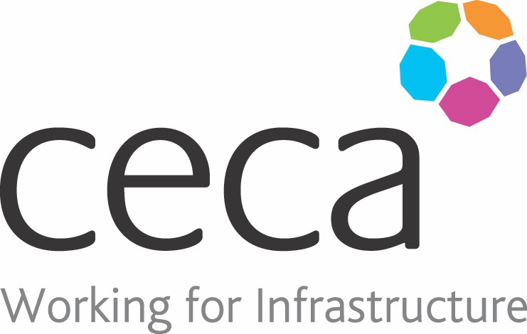
CECA Midlands E Learning

BOBULLYING & HARASSMENT - FOR MANAGERS
Having a positive workplace culture is crucial in attracting and retainingrespectful, hardworking and skilledemployees.
And this starts with YOU – the leaders and management.
There is no room for Bullying & Harassment in the workplace, it shouldn’t happen under any circumstances.
This course has been designed for you to learn how to best manage your team. We take you through it all – identifying, preventing, handling and combating negative behaviour in the workplace. This course covers informal approaches, formal policies and procedures, legal considerations, and the harmful effect that bullying and harassment can have on your business.
It also looks at the fine line between bullying and strong management, and how management can avoid crossing that line.
This course works in conjunction with our “Bullying and Harassment in the Workplace – Employees” course.

Learning overview:
- What are Bullying and Harassment? Differences and Similarities
- How do I tackle bullying
- How can I prevent bullying from happening

Assessment:
This training programme concludes with a 20 question multiple choice test with printable certificate. In addition, brief in-course questionnaires guide the user through the sections of the training, and are designed to reinforce learning and ensure maximum user engagement throughout.

Cost: Registration fee £20 + VAT for full and associate CECA Midlands members.
Award: E learning certificate

Company name: |  | Company contact name:
Company email: |  | Contact tel:
Delegate name: |  | Job title:
Delegate email: |  | Delegate tel:
Accounts Name: |  | Accounts email:

Booking Form – please complete and return to admin@cecamidlands.co.uk one per delegate.
BULLYING & HARASSMENT – FOR MANAGERS

