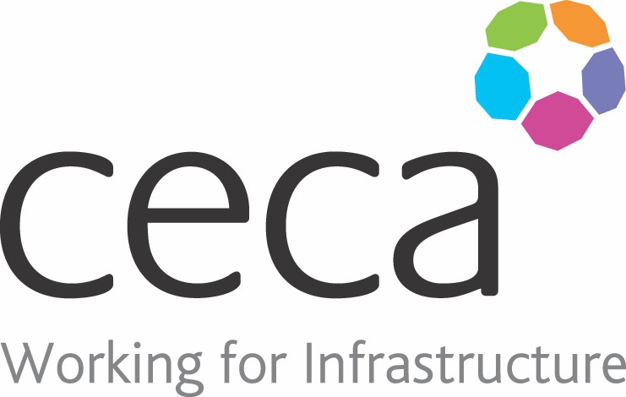
CECA Midlands E Learning

BUSINESS COMPLIANCE ESSENTIALS
All of your employees need to have a solid understanding of business compliance and so this course will give them the foundations of what is required by the many laws that organisations have to comply with. including Data Protection (GDPR), Fraud, Money-Laundering, Anti-Bribery and others.
This is the perfect course for existing employees, to ensure that they know what your organisation have to face but also for new starters. This course offers general guidance on a wide range of subjects that will help employees at all levels to understand their responsibilities under current legislation.
However, if you want to give your staff a more in-depth knowledge on any particular subject, there are more detailed subjects for each in our main course list.

Learning overview:
- To be advised

Assessment:
This training programme concludes with a 20 question multiple choice test with printable certificate. In addition, brief in-course questionnaires guide the user through the sections of the training, and are designed to reinforce learning and ensure maximum user engagement throughout.

Cost: Registration fee £20 + VAT for full and associate CECA Midlands members.
Award: E learning certificate

Company name: |  | Company contact name:
Company email: |  | Contact tel:
Delegate name: |  | Job title:
Delegate email: |  | Delegate tel:
Accounts Name: |  | Accounts email:

++
Booking Form – please complete and return to admin@cecamidlands.co.uk one per delegate.
BUSINESS COMPLIANCE ESSENTIALS

