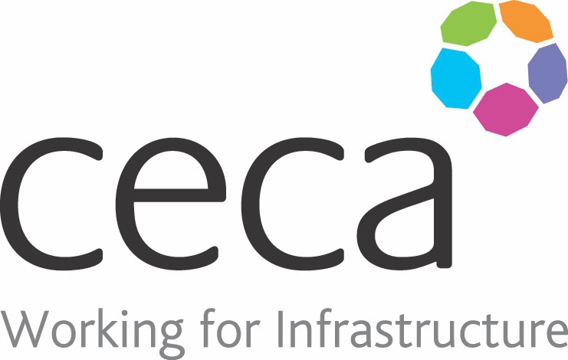
CECA Midlands E Learning

CDM REGULATIONS
The construction industry is arguably one of the most dangerous sectors to work for and it’s for this reason that the Construction (Design & Management) Regulations were first introduced.
The CDM Regulations help make the chaos of a construction project controllable – from start to finish and beyond. By creating roles and responsibilities for key duty holders throughout a construction project, they ensure that Health & Safety protocols are effectively managed by the right people, and that they are communicated to and followed by everyone.
This CDM Training course breaks the regulations down into three simple sections; the roles and responsibilities of everyone involved; what needs to be planned for at each stage of a construction project; and what needs to be considered in order to keep a construction site safe.
” course.

Learning overview:
- What are CDM regulations
- Planning
- Safe sites

Assessment:
This training programme concludes with a 20 question multiple choice test with printable certificate. In addition, brief in-course questionnaires guide the user through the sections of the training, and are designed to reinforce learning and ensure maximum user engagement throughout.

Cost: Registration fee £20 + VAT for full and associate CECA Midlands members.
Award: E learning certificate

Company name: |  | Company contact name:
Company email: |  | Contact tel:
Delegate name: |  | Job title:
Delegate email: |  | Delegate tel:
Accounts Name: |  | Accounts email:

Booking Form – please complete and return to admin@cecamidlands.co.uk one per delegate.
CDM REGULATIONS

