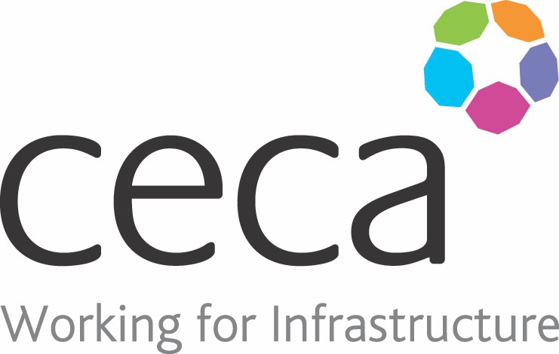
CECA Midlands E Learning

COSHH AWARENESS TRAINING
The concise and easy-to-follow course format allows you to learn about the risks associated with hazardous substances, as well as understand control measures and emergency procedures. This course identifies which substances can be hazardous and how they can be harmful; it also looks at the everyday storage and use of chemicals and hazardous substances, as well as covering CoSHH risk assessments and what they are used for.
By providing effective CoSHH training, employers can help to ensure that everyone in the workplace is competent to carry out their work safely. All levels of staff and management should be able to recognise the potential hazards posed by their work, be able to take action to reduce or eliminate the risks and understand the role of personal protection in ensuring good occupational health.
.

Learning overview:
- Hazardous substances
- Warning symbols
- Hazards/Risks
- Protection

Assessment:
This training programme concludes with a 20 question multiple choice test with printable certificate. In addition, brief in-course questionnaires guide the user through the sections of the training, and are designed to reinforce learning and ensure maximum user engagement throughout.

Cost: Registration fee £20 + VAT for full and associate CECA Midlands members.
Award: E learning certificate

Company name: |  | Company contact name:
Company email: |  | Contact tel:
Delegate name: |  | Job title:
Delegate email: |  | Delegate tel:
Accounts Name: |  | Accounts email:

Booking Form – please complete and return to admin@cecamidlands.co.uk one per delegate.
COSHH AWARENESS TRAINING

