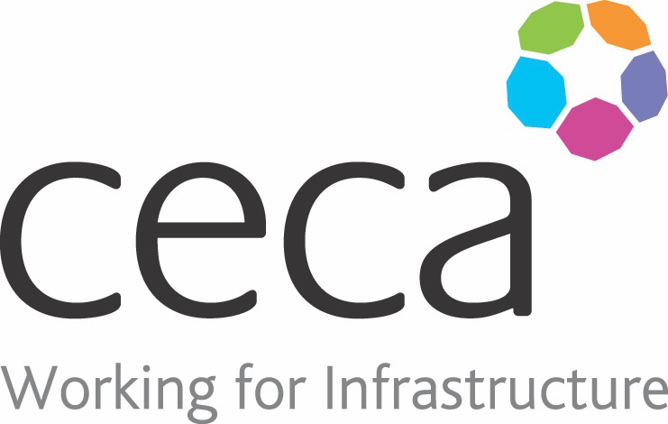
CECA Midlands E Learning

COMMUNICATION SKILLS
Sometimes there is a mismatch between what we think we are saying and how it is received by the other party. Working on our communication skills, makes us far more likely to be able to express ourselves in a way that others can clearly understand.
Despite nearly 90% of people feeling that effective communication is extremely important, 80% of people rate their own communication skills as either’ average’ or ‘poor’.
The short, impactful course can be undertaken by anyone who wants to improve communication by learning the basics and foundations of effective communication. It can also be used as a refresher for those who consider themselves good communicators but want to ensure they are still familiar with good practices.

Learning overview:
- How Does Communication Work?
- Overcoming Barriers to Good Communication

Assessment:
This training programme concludes with a 20 question multiple choice test with printable certificate. In addition, brief in-course questionnaires guide the user through the sections of the training, and are designed to reinforce learning and ensure maximum user engagement throughout.

Cost: Registration fee £20 + VAT for full and associate CECA Midlands members.
Award: E learning certificate

Company name: |  | Company contact name:
Company email: |  | Contact tel:
Delegate name: |  | Job title:
Delegate email: |  | Delegate tel:
Accounts Name: |  | Accounts email:

Booking Form – please complete and return to admin@cecamidlands.co.uk one per delegate.
COMMUNICATION SKILLS

