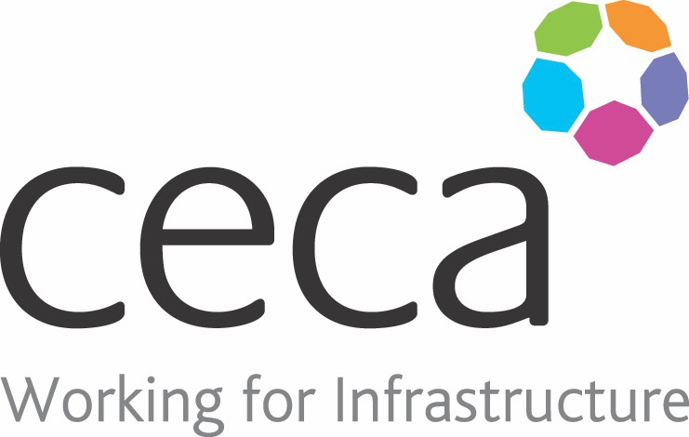
CECA Midlands E Learning

CONFIDENCE BUILDING
The importance of having confidence is paramount if you want to get on in life and work. People who lack confidence tend to concentrate on the impact others have on them, instead of focusing on the impact that they have on others.
This short course will help you to realise that it’s what you do that matters and how you feel about yourself, not what others do to you or feel about you.
This course is aimed at giving you added confidence in the eyes of your colleagues, clients, or customers so that you can be seen to be showing better levels of professionalism.

Learning overview:
- What is ‘Confidence’?
- Increasing Your Confidence

Assessment:
This training programme concludes with a 20 question multiple choice test with printable certificate. In addition, brief in-course questionnaires guide the user through the sections of the training, and are designed to reinforce learning and ensure maximum user engagement throughout.

Cost: Registration fee £20 + VAT for full and associate CECA Midlands members.
Award: E learning certificate

Company name: |  | Company contact name:
Company email: |  | Contact tel:
Delegate name: |  | Job title:
Delegate email: |  | Delegate tel:
Accounts Name: |  | Accounts email:

Booking Form – please complete and return to admin@cecamidlands.co.uk one per delegate.
CONFIDENCE BUILDING

