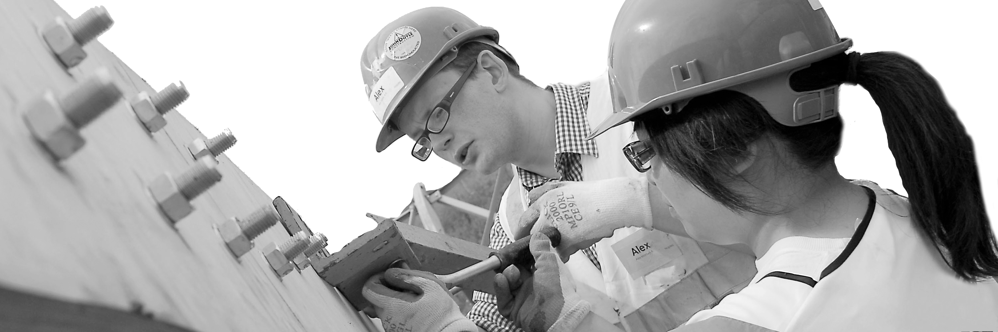
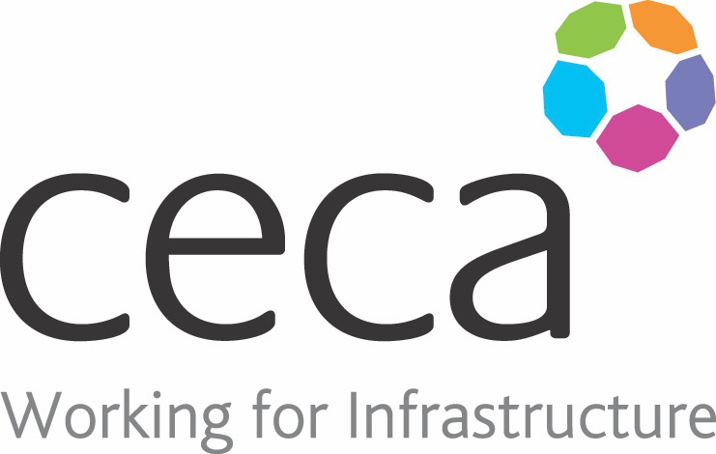
CECA Midlands E Learning

CONFINED SPACE WORKING AWARENESS
A ‘confined space’ is defined as anywhere that is substantially enclosed (although not necessarily entirely), where a person may be at risk from injury from hazardous substances or lack of oxygen.
Every year, around 15 UK workers are killed working in confined spaces and many more are injured. This kind of work can be extremely dangerous if the correct procedures are not followed.
This Confined Space training programme defines what confined spaces are, why they can be dangerous, what the law says must be done, and how the risks can be minimised. It covers the different kinds of confined spaces, as well as how to perform proper risk assessments and understand correct emergency procedures.
Confined Space training is particularly important for those working in Construction, Installation/Maintenance and Manufacturing (as well as anyone carrying out repair work or working with potentially dangerous substances in poorly ventilated areas).
However, we would suggest that it should be used as a refresher once a person has undertaken practical training.

Learning overview:
- What is a confined space
- Why are they dangerous
- Legal duties and responsibilities
- Preparing for entry

Assessment:
This training programme concludes with a 20 question multiple choice test with printable certificate. In addition, brief in-course questionnaires guide the user through the sections of the training, and are designed to reinforce learning and ensure maximum user engagement throughout.

Cost: Registration fee £20 + VAT for full and associate CECA Midlands members.
Award: E learning certificate

Company name: |  | Company contact name:
Company email: |  | Contact tel:
Delegate name: |  | Job title:
Delegate email: |  | Delegate tel:
Accounts Name: |  | Accounts email:

Booking Form – please complete and return to admin@cecamidlands.co.uk one per delegate.
CONFINED SPACES AWARENESS

