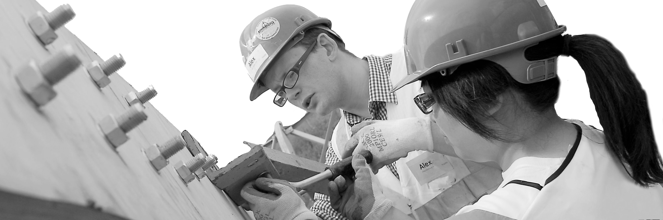
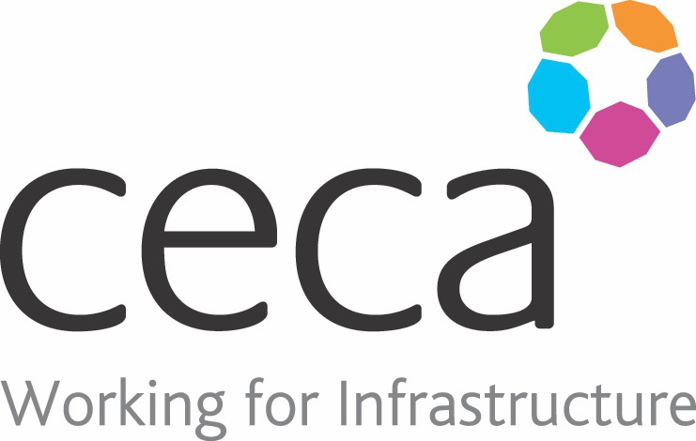
CECA Midlands E Learning

CONFLICT RESOLUTION TRAINING
At work, or outside of it, conflict is something that happens all too frequently in one degree or another and it can have a bad impact on relationships. Managing conflict in the right way will bring positive results to a negative situation.
Conflict arises in most organisation and at any time – in fact anywhere where people who have different beliefs, opinions and ways of working have to work alongside others.
Communicating positive messages is one of the most important skills in life – and one that does not normally figure in training plans! Anyone who has to deal with the differences, or demands, of employees or colleagues, managers, suppliers or clients needs to enhance their communication skills.
A conflict that is handled poorly, can cause immense damage to an organisation’s productivity, hence why Conflict Resolution Training is essential for giving you the best ways for dealing with conflict.

Learning overview:
- Introduction to conflict
- Tips and techniques
- Handling serious conflict

Assessment:
This training programme concludes with a 20 question multiple choice test with printable certificate. In addition, brief in-course questionnaires guide the user through the sections of the training, and are designed to reinforce learning and ensure maximum user engagement throughout.

Cost: Registration fee £20 + VAT for full and associate CECA Midlands members.
Award: E learning certificate

Company name: |  | Company contact name:
Company email: |  | Contact tel:
Delegate name: |  | Job title:
Delegate email: |  | Delegate tel:
Accounts Name: |  | Accounts email:

Booking Form – please complete and return to admin@cecamidlands.co.uk one per delegate.
CONFLICT RESOLUTION

