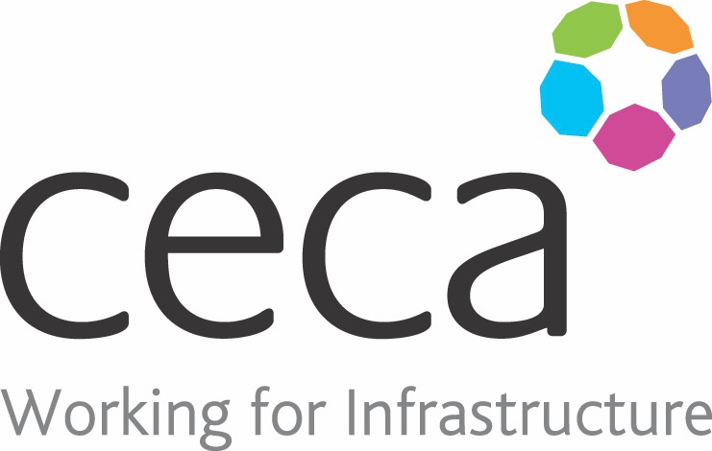
CECA Midlands E Learning

CYBER SERCURITY AWARENESS
You don’t have to be a multi-national or Government organisation to be at risk! Cyber security is a vital part of an organisation’s information security measures and whether it’s by dodgy e-mails, going on to false websites, phishing or direct computer attacks, the threat is massive.
Cyber-crime costs UK businesses an estimated £30 billion each year and causes massive disruption, around half of all UK businesses having had at least one attempt to breach their security.
This course has therefore been designed for everyone in an organisation as ‘the weakest link’ is what a fraudster is looking for.
The course includes practical steps that will help to protect computers, networks, programmes and data from unauthorised access and how we can help to safeguard the systems and information we use.

Learning overview:
- Cyber security overview
- What you can do
- Security breach

Assessment:
This training programme concludes with a 20 question multiple choice test with printable certificate. In addition, brief in-course questionnaires guide the user through the sections of the training, and are designed to reinforce learning and ensure maximum user engagement throughout.

Cost: Registration fee £20 + VAT for full and associate CECA Midlands members.
Award: E learning certificate

Company name: |  | Company contact name:
Company email: |  | Contact tel:
Delegate name: |  | Job title:
Delegate email: |  | Delegate tel:
Accounts Name: |  | Accounts email:

Booking Form – please complete and return to admin@cecamidlands.co.uk one per delegate.
CYBER SECURITY AWARENESS

