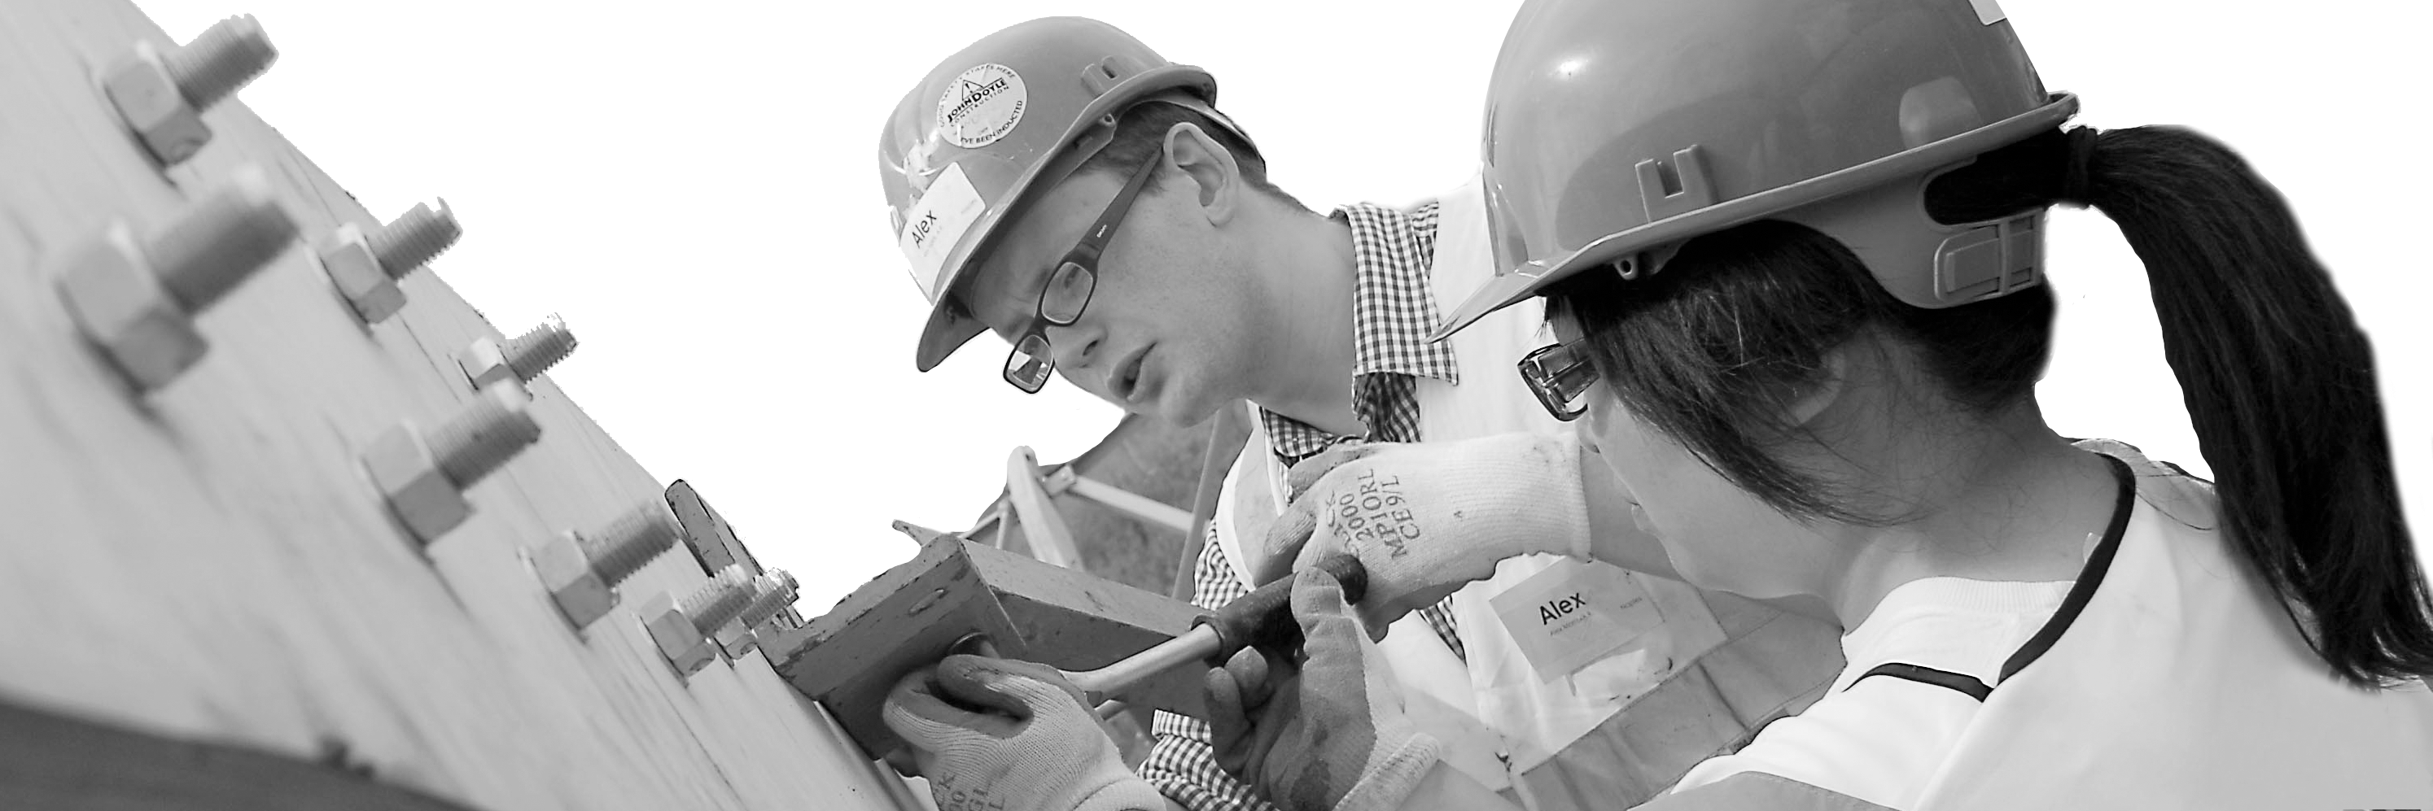
CECA Midlands E Learning

DISLAY SCREEN EQUIPMENT
Everyone who regularly uses a computer legally requires computer health and safety training: This is also known as ‘DSE’ (Display Screen Equipment) or VDU (Visual Display Unit Training).
Whether you work with a desktop computer, laptop or handheld device, it is legally required that your employer provides training to help you understand the potential health risks of this type of work, as well as how best to avoid them. Taking just 30 minutes to complete, our Display Screen Equipment training programme will show you how to carry out a DSE risk assessment, as well as better arrange your existing workplace equipment to minimise common negative symptoms associated with extended periods of time spent at a computer (such as eye strain, backache, etc.).

Learning overview:
- At your desk
- On your desk
- Environment
- Portable devices
- Exercises
- DSE assessment

Assessment:
This training programme concludes with a 20 question multiple choice test with printable certificate. In addition, brief in-course questionnaires guide the user through the sections of the training, and are designed to reinforce learning and ensure maximum user engagement throughout.

Cost: Registration fee £20 + VAT for full and associate CECA Midlands members.
Award: E learning certificate

Company name: |  | Company contact name:
Company email: |  | Contact tel:
Delegate name: |  | Job title:
Delegate email: |  | Delegate tel:
Accounts Name: |  | Accounts email:

Booking Form – please complete and return to admin@cecamidlands.co.uk one per delegate.
DISPLAY SCREEN EQUIPMENT

