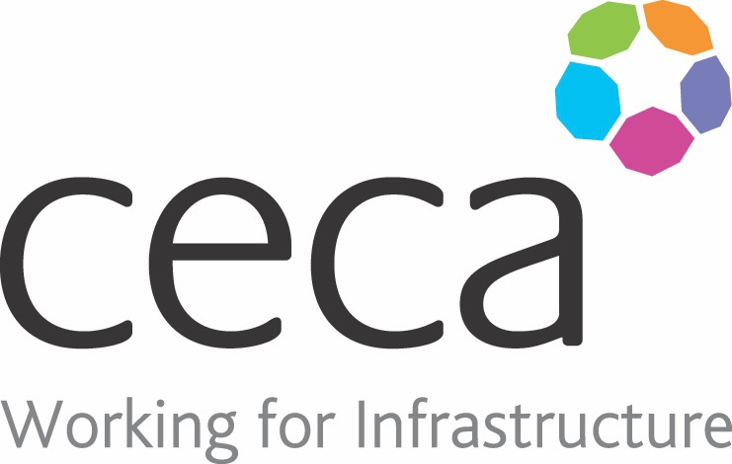
CECA Midlands E Learning

DRIVER AWARENESS
Driving is something you probably do almost every day and it’s easy to become complacent, particularly if you are regularly travelling the same route. This programme aims to be a good reminder of general road safety – things you can do to keep yourself and other road users safe.
If you drive 25,000 or more work-miles, it’s probably the most dangerous part of your job. Every week, around 200 road deaths or serious injuries involve someone driving for work. With around 3 million company cars on the road, 1 in 3 will be involved in an accident of some kind every year.
This training programme aims to highlight some of the daily risks when driving. It’s about promoting an awareness of what’s going on around you, where the other drivers and road users are, what they are doing and what they might do next. It’s also about properly preparing for a journey and checking your vehicle, as well as knowing what to do in case you are involved in an accident.

Learning overview:
- Responsabilties
- Safe driving
- Safe journey
- Safe vehicle

Assessment:
This training programme concludes with a 20 question multiple choice test with printable certificate. In addition, brief in-course questionnaires guide the user through the sections of the training, and are designed to reinforce learning and ensure maximum user engagement throughout.

Cost: Registration fee £20 + VAT for full and associate CECA Midlands members.
Award: E learning certificate

Company name: |  | Company contact name:
Company email: |  | Contact tel:
Delegate name: |  | Job title:
Delegate email: |  | Delegate tel:
Accounts Name: |  | Accounts email:

Booking Form – please complete and return to admin@cecamidlands.co.uk one per delegate.
DRIVER AWARENESS

