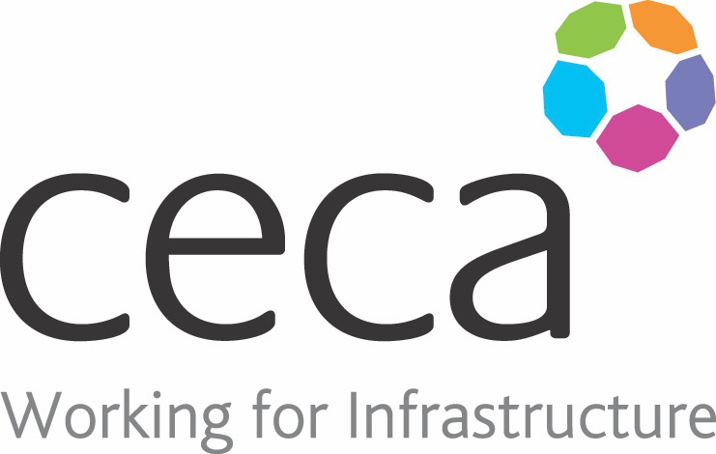
CECA Midlands E Learning

DRUG & ALCOHOL AWARENESS
Every year thousands of lives are ruined by alcohol and drug abuse. Private life suffers, health suffers, jobs suffer.
Just one person in the workplace affected by alcohol or drugs can put everyone at risk.
This course has been written to raise general awareness, so that it doesn’t become a problem at work. It has been written for anyone to use, whether you are an employer, manager or employee. It’s for your information – it will help you recognise a problem, either in someone who works for you, in yourself, or in a colleague.

Learning overview:
- The problem
- Effects on health
- People and policies

Assessment:
This training programme concludes with a 20 question multiple choice test with printable certificate. In addition, brief in-course questionnaires guide the user through the sections of the training, and are designed to reinforce learning and ensure maximum user engagement throughout.

Cost: Registration fee £20 + VAT for full and associate CECA Midlands members.
Award: E learning certificate

Company name: |  | Company contact name:
Company email: |  | Contact tel:
Delegate name: |  | Job title:
Delegate email: |  | Delegate tel:
Accounts Name: |  | Accounts email:

Booking Form – please complete and return to admin@cecamidlands.co.uk one per delegate.
DRUG & ALCOHOL AWARENESS

