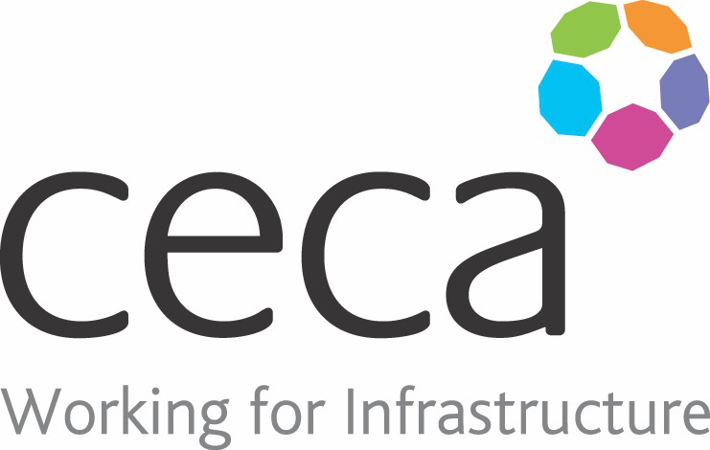
CECA Midlands E Learning

Effective Remote Working
This course covers guidance and tips on how to manage time effectively, set boundaries and identify your most productive times of the day. It provides an overview of the importance of creating structure to your working day and creating a productive workspace. These include a basic understanding of DSE, manual handling and even employee mental health.
Being a remote worker doesn’t mean you are detached from the office, as there are a range of communication methods that ensure you can be reached and be heard. The skills you will learn in this course will help you as a remote worker carry out your role safely and effectively at home or from any alternative locations from the office.
Happy and productive employees will achieve greater job satisfaction so providing the tools to work effectively from home is vital.

Topics Covered:
- Setting up productive workspace
- Planning the day
- Communication

Assessment:
This training programme concludes with a 20 question multiple choice test with printable certificate. In addition, brief in-course questionnaires guide the user through the sections of the training, and are designed to reinforce learning and ensure maximum user engagement throughout.
Cost: Registration fee £20 +VAT for full and associate CECA Midlands members
Award: E learning certificate

Company name: |  | Company contact name:
Company email: |  | Contact tel:
Delegate name: |  | Job title:
Delegate email: |  | Delegate tel:
Accounts Name: |  | Accounts email:

Booking Form – please complete and return to admin@cecamidlands.co.uk one per delegate.
Effective Remote Working

