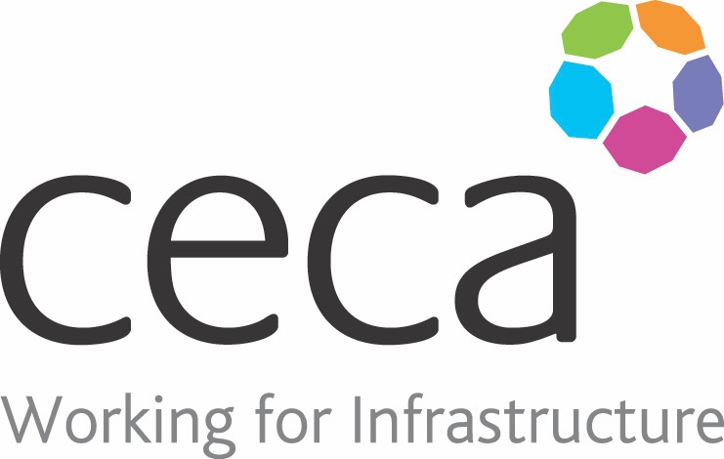
CECA Midlands E Learning

ELECTRICAL SAFETY IN THE WORKPLACE
This training is designed to help you understand why electrical safety is so important, and explains what you can do to keep yourself and others safe around electrical and electronic equipment.
Electrical safety isn’t only an issue for electricians or people whose job is specifically to do with electricity; it’s important no matter what job you do or what industry you work in. Electrical safety helps prevent you and other people from being injured or even killed by electrical hazards. Each year there are about 30 fatal electrical accidents, with roughly 1,000 workplace injuries involving electricity.
This course looks at the laws surrounding electricity at work, as well as covering best practice for safe use of electrical appliances and what to do in emergency situations.

Learning overview:
- Working safely
- Injury and emergency procedures
- Electricity and the law

Assessment:
This training programme concludes with a 20 question multiple choice test with printable certificate. In addition, brief in-course questionnaires guide the user through the sections of the training, and are designed to reinforce learning and ensure maximum user engagement throughout.

Cost: Registration fee £20 + VAT for full and associate CECA Midlands members.
Award: E learning certificate

Company name: |  | Company contact name:
Company email: |  | Contact tel:
Delegate name: |  | Job title:
Delegate email: |  | Delegate tel:
Accounts Name: |  | Accounts email:

Booking Form – please complete and return to admin@cecamidlands.co.uk one per delegate.
ELECTRICAL SAFETY IN THE WORKPLACE

