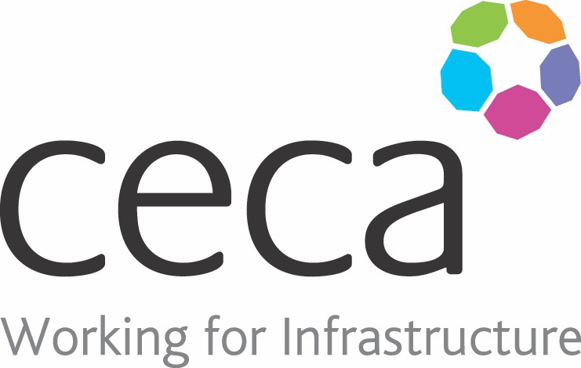
CECA Midlands E Learning

EMERGENCY FIRST AID AT WORK REFRESHER
HSE recommend that anyone who has successfully qualified in First Aid, should
have a refresher each year, particularly as the chances of having to use the
knowledge and skills, may not occur for years, if at all, and it is easy to forget what
you have learnt.
This course is the ideal vehicle to refresh that knowledge and skills, although it
obviously is not a practical course. It will give First Aiders a reminder about areas
such as primary survey, secondary survey and a recap of some of the treatments
that they may be asked to provide.

Learning overview:
- Primary survey
- Secondary survey
- First aid treatment

Assessment:
This training programme concludes with a 20 question multiple choice test with printable certificate. In addition, brief in-course questionnaires guide the user through the sections of the training, and are designed to reinforce learning and ensure maximum user engagement throughout.

Cost: Registration fee £20 + VAT for full and associate CECA Midlands members.
Award: E learning certificate

Company name: |  | Company contact name:
Company email: |  | Contact tel:
Delegate name: |  | Job title:
Delegate email: |  | Delegate tel:
Accounts Name: |  | Accounts email:

Booking Form – please complete and return to admin@cecamidlands.co.uk one per delegate.
EMERGENCY FIRST AID AT WORK REFRESHER

