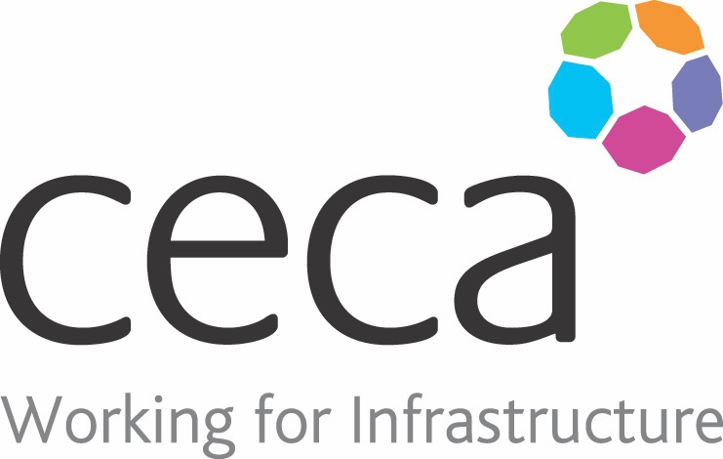
CECA Midlands E Learning

ENVIRONMENTAL AWARENESS
This course is designed to introduce staff and management at all levels to the issue of environmental responsibility, as well as looking at what can be done to reduce negative environmental impact from our day to day activities.
We all know that our environment is under threat and that changes must be made to protect it. In this programme we make it clear that it’s not just big companies that have a responsibility to make changes – or indeed companies that deal with hazardous materials or waste disposal – it’s something that concerns absolutely all of us.
This programme looks at the problems our environment is facing. It looks at our responsibilities and wider environmental awareness, as well as covering the various legislation that relates to environmental responsibility for organisations of all types and sizes.

Learning overview:
- The environment
- Sustainability
- The environment and workplace

Assessment:
This training programme concludes with a 20 question multiple choice test with printable certificate. In addition, brief in-course questionnaires guide the user through the sections of the training, and are designed to reinforce learning and ensure maximum user engagement throughout.

Cost: Registration fee £20 + VAT for full and associate CECA Midlands members.
Award: E learning certificate

Company name: |  | Company contact name:
Company email: |  | Contact tel:
Delegate name: |  | Job title:
Delegate email: |  | Delegate tel:
Accounts Name: |  | Accounts email:

Booking Form – please complete and return to admin@cecamidlands.co.uk one per delegate.
ENVIRONMENTAL AWARENESS

