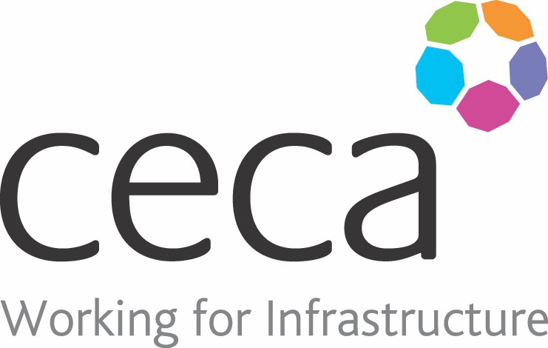
CECA Midlands E Learning

EQUALITY & DIVERSITY AWARENESS
Equality and diversity is all about treating people fairly and with respect, no matter what their differences may be.This training programme looks at how we behave at work and how our behaviour may affect those around us. It addresses unacceptable behaviour, stereotyping and discrimination as well as introducing characteristics protected by the Equality Act – suggesting ways in which to build a more supportive, harmonious workplace.
An open and inclusive workplace has many benefits – both to the organisation and to individuals; such benefits include an increase in morale, better staff retention and improved company reputation. Where employees are treated fairly and with respect, this will be reflected in their work – with better working environments leading to better overall performance and productivity.

Learning overview:
- Unacceptable behaviour
- Protected characteristics
- The benefits of equality and diversity

Assessment:
This training programme concludes with a 20 question multiple choice test with printable certificate. In addition, brief in-course questionnaires guide the user through the sections of the training, and are designed to reinforce learning and ensure maximum user engagement throughout.

Cost: Registration fee £20 + VAT for full and associate CECA Midlands members.
Award: E learning certificate

Company name: |  | Company contact name:
Company email: |  | Contact tel:
Delegate name: |  | Job title:
Delegate email: |  | Delegate tel:
Accounts Name: |  | Accounts email:

Booking Form – please complete and return to admin@cecamidlands.co.uk one per delegate.
EQUALITY & DIVERSITY

