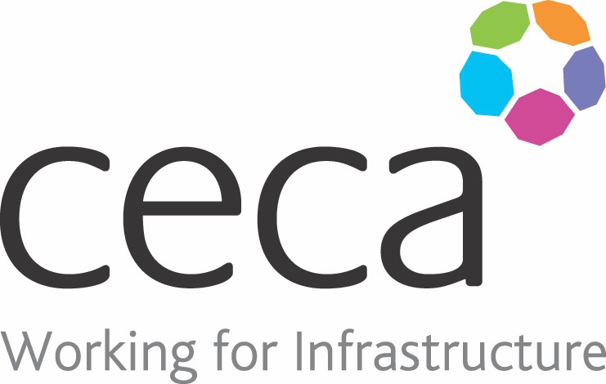
CECA Midlands E Learning

EYE PROTECTION
Eye injuries are probably more common than you think. In fact, over 2,000 people per day sustain injuries to their eyes!
Whether that’s through strain or from working without the correct PPE, it can always be prevented. As your eyes are so delicate and cannot be easily fixed, it is essential that you know how to treat them in the healthiest way possible.
Eye injuries are one of the most common non-fatal injuries in the workplace and as many as 90% of them could have been prevented by wearing the right eye protection.
This Eye Protection Training course was designed to tackle the risks of damage to the eyes and reduce the chances of any vision-altering accidents.
Learning overview:
- Risks and hazards
- Protecting yourself
- When accidents happen
- Identifying risk and managing safely

Assessment:
This training programme concludes with a 20 question multiple choice test with printable certificate. In addition, brief in-course questionnaires guide the user through the sections of the training, and are designed to reinforce learning and ensure maximum user engagement throughout.

Cost: Registration fee £20 + VAT for full and associate CECA Midlands members.
Award: E learning certificate

Company name: |  | Company contact name:
Company email: |  | Contact tel:
Delegate name: |  | Job title:
Delegate email: |  | Delegate tel:
Accounts Name: |  | Accounts email:

Booking Form – please complete and return to admin@cecamidlands.co.uk one per delegate.
EYE PROTECTION

