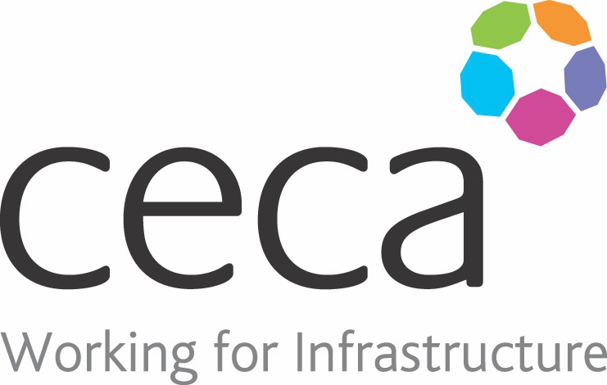
CECA Midlands E Learning

FIRE AWARENESS
Fire Awareness Training is a legal requirement for every workplace, and under the Construction Design and Management Regulations (CDM), and the Health and Safety at Work Act 1974, you are obliged to ensure this training is undertaken by all staff.
This training programme has been written for people who work in the construction industry, as it includes information which is particularly relevant when working on building sites.
This online e-learning programme is an effective and hassle-free way to ensure that you comply with current legislation – as well as providing an easily accessible record of who has completed the training. This Fire Awareness course will introduce you to fire signage, explain how different extinguishers are needed for different types of fires and show you how to use them. It also looks at safe evacuation and what you should do in emergency situations.

Learning overview:
- The nature of fire
- Fire signage
- Fire hazards
- Discovering a fire
- Fire extinguishers

Assessment:
This training programme concludes with a 20 question multiple choice test with printable certificate. In addition, brief in-course questionnaires guide the user through the sections of the training, and are designed to reinforce learning and ensure maximum user engagement throughout.

Cost: Registration fee £20 + VAT for full and associate CECA Midlands members.
Award: E learning certificate

Company name: |  | Company contact name:
Company email: |  | Contact tel:
Delegate name: |  | Job title:
Delegate email: |  | Delegate tel:
Accounts Name: |  | Accounts email:

Booking Form – please complete and return to admin@cecamidlands.co.uk one per delegate.
FIRE AWARENESS

