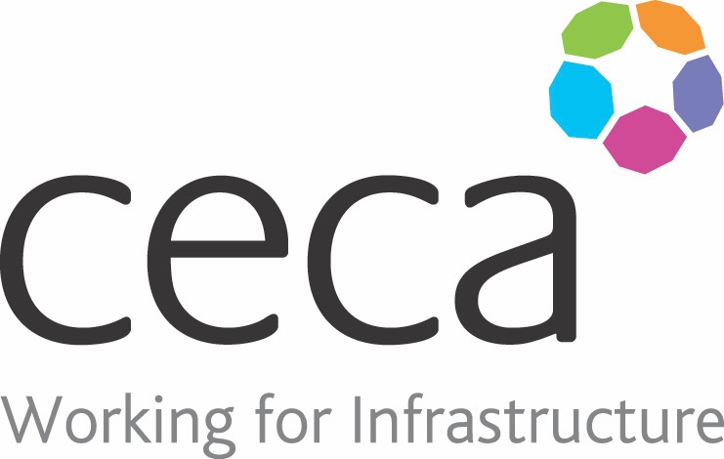
CECA Midlands E Learning

FIRE EXTINGUISHERS
There is a natural tendency for a person to try to use an extinguisher on a fire. But it is vital that they only try to do so when there is no danger and they should follow the ‘ONE FIRE, ONE ‘ rule. If it might take more than one extinguisher to put out the fire, then it’s too big to tackle and they need to evacuate immediately.
However, when there is a chance of putting out a fire with an extinguisher, there is a danger that by using the wrong type of unit, there will be added danger.
A person must therefore know what kind of fire extinguisher should be used for each class of fire and the safety measure to take when using an extinguisher.

Assessment:
This training programme concludes with a 20 question multiple choice test with printable certificate. In addition, brief in-course questionnaires guide the user through the sections of the training, and are designed to reinforce learning and ensure maximum user engagement throughout.

Cost: Registration fee £20 + VAT for full and associate CECA Midlands members.
Award: E learning certificate

Company name: |  | Company contact name:
Company email: |  | Contact tel:
Delegate name: |  | Job title:
Delegate email: |  | Delegate tel:
Accounts Name: |  | Accounts email:

Booking Form – please complete and return to admin@cecamidlands.co.uk one per delegate.
FIRE EXTINGUISHERS

