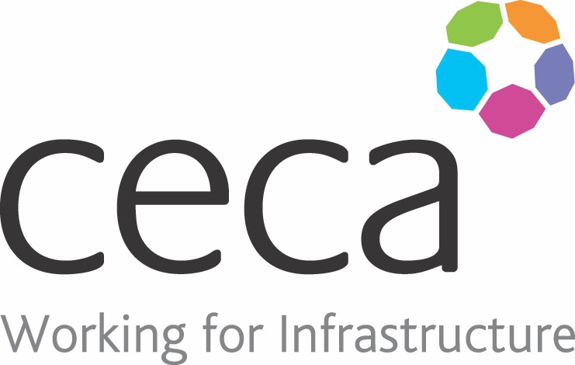
CECA Midlands E Learning

FIRE WARDEN (CONSTRUCTION)
This course is a complete, in-depth Fire Warden course aimed specifically at those working in the Construction industry.
Assigning Fire Warden duties to a responsible person on site is a key part of ensuring good health and safety and demonstrates a commitment to implementing sound emergency fire procedures.
This course provides everything you need to be able to demonstrate competence in the role of Fire Warden or Fire Marshal including your duties under fire legislation, as well as looking at fire prevention measures, the correct use of fire extinguishers, and how to organise a fire drill.

Learning overview:
- Background
- Fire prevention
- Fire evacuation
- Fire extinguishers and classes
- Legislation overview

Assessment:
This training programme concludes with a 20 question multiple choice test with printable certificate. In addition, brief in-course questionnaires guide the user through the sections of the training, and are designed to reinforce learning and ensure maximum user engagement throughout.

Cost: Registration fee £20 + VAT for full and associate CECA Midlands members.
Award: E learning certificate

Company name: |  | Company contact name:
Company email: |  | Contact tel:
Delegate name: |  | Job title:
Delegate email: |  | Delegate tel:
Accounts Name: |  | Accounts email:

Booking Form – please complete and return to admin@cecamidlands.co.uk one per delegate.
FIRE WARDEN

