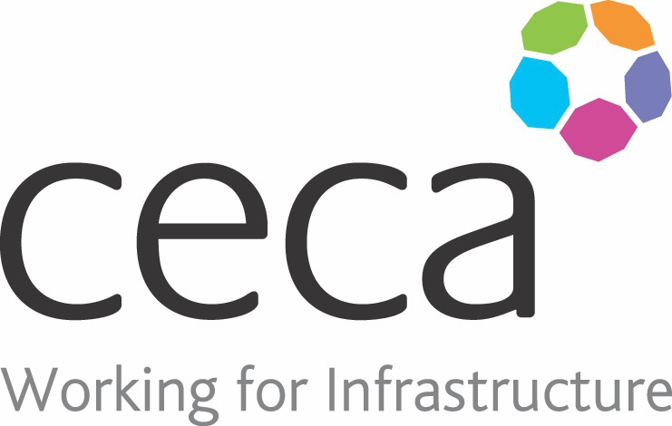
CECA Midlands E Learning

FIRST AID APPOINTED PERSON

For many smaller low risk companies, the legal minimum for first aid provision is to have someone in their company who simply looks after first aid – this is the First Aid Appointed Person.
This e-learning programme explains exactly what the role of First Aid Appointed Person requires a member of staff to do, as well as introducing best practice in the event of an accident or injury at work.
It is intended that this programme is used alongside First Aid Requirements in the Workplace (including RIDDOR). This programme will indicate the need for a first aid appointed person, as well as explaining the benefits to your organisation. Free trial and online demo available.

Learning overview:
- Health & Safety requirements
- Dealing with an emergency

Assessment:
This training programme concludes with a 20 question multiple choice test with printable certificate. In addition, brief in-course questionnaires guide the user through the sections of the training, and are designed to reinforce learning and ensure maximum user engagement throughout.

Cost: Registration fee £20 + VAT for full and associate CECA Midlands members.
Award: E learning certificate

Company name: |  | Company contact name:
Company email: |  | Contact tel:
Delegate name: |  | Job title:
Delegate email: |  | Delegate tel:
Accounts Name: |  | Accounts email:

Booking Form – please complete and return to admin@cecamidlands.co.uk one per delegate.
FIRST AID FOR APPOINTED PERSON

