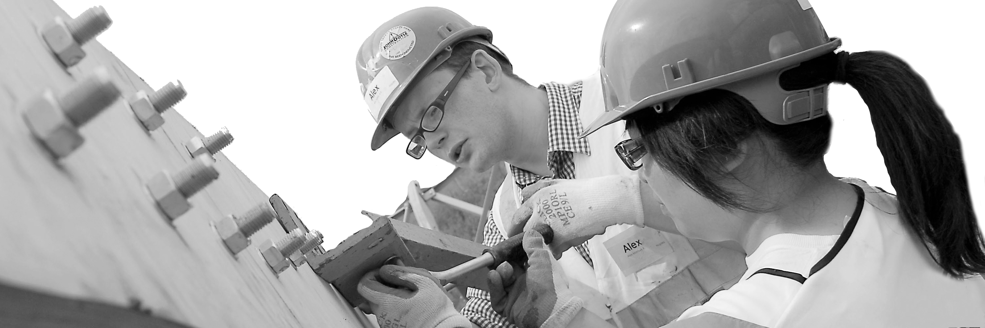
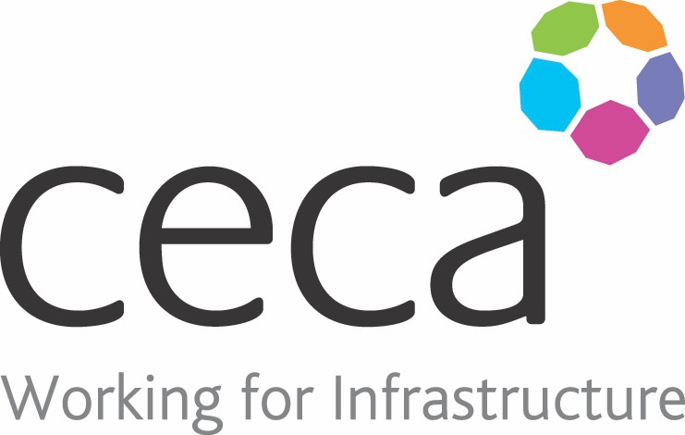
CECA Midlands E Learning

FIRST AID AT WORK REFRESHER
HSE recommend that anyone who has successfully qualified in First Aid, should have a refresher each year, particularly as the chances of having to use the knowledge and skills, may not occur for years, if at all and it is easy to forget what you have learnt.
This course is the ideal vehicle to refresh that knowledge and skills, although it obviously is not a practical course. It will give First Aiders a reminder about areas such as primary survey, secondary survey and CPR and a recap of some of the treatments that they may be asked to provide.

Learning overview:
- Assessing the situation and what may be required
- Finding out what is wrong with the person
- Essential procedures and treatments
- Advanced – for those with 3 day first aid at work qualification

Assessment:
This training programme concludes with a 20 question multiple choice test with printable certificate. In addition, brief in-course questionnaires guide the user through the sections of the training, and are designed to reinforce learning and ensure maximum user engagement throughout.

Cost: Registration fee £20 + VAT for full and associate CECA Midlands members.
Award: E learning certificate

Company name: |  | Company contact name:
Company email: |  | Contact tel:
Delegate name: |  | Job title:
Delegate email: |  | Delegate tel:
Accounts Name: |  | Accounts email:

Booking Form – please complete and return to admin@cecamidlands.co.uk one per delegate.
FIRST AID AT WORK REFRESHER

