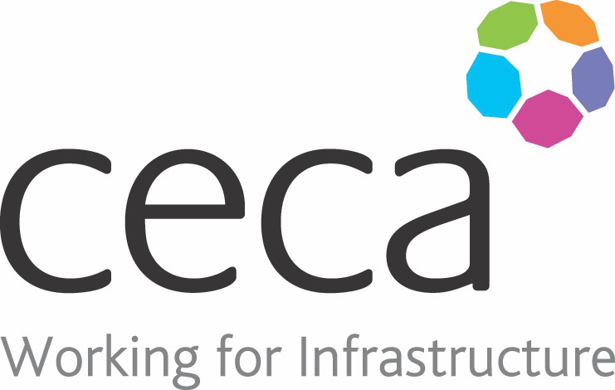
CECA Midlands E Learning

FRAUD AWARENESS & PREVENTION

Fraud is often as simple as someone stealing money from an organisation but it can also be using information such as trade secrets, personal records of customers, or performance, to gain a personal benefit. Action Fraud received over 52,000 reports of fraud in the UK alone in the 12 months to March 2018.
Preventing fraud will prevent monetary loses (sometimes major ones) as well as prevent delicate and private information being shared and distributed.
This course provides management with knowledge on what the signs of fraudulent activity might be, what to do if a risk or suspicion of fraud is encountered and how to raise awareness of fraud.
There is no strict set of rules to follow that will guarantee that an organisation will not encounter fraud but this course will equip people on how best to manage the situation and avoid being a victim.
Fraud can make an individual or group feel unsafe or as if their privacy has been violated. Action Fraud reported in September 2017 that around 272,980 fraud offences (in the UK alone) had been carried out in the previous 12 months.

Learning overview:
- What is fraud?
- Detecting fraud
- Preventing fraud
- External fraud
- Reporting fraud

Assessment:
This training programme concludes with a 20 question multiple choice test with printable certificate. In addition, brief in-course questionnaires guide the user through the sections of the training, and are designed to reinforce learning and ensure maximum user engagement throughout.

Cost: Registration fee £20 + VAT for full and associate CECA Midlands members.
Award: E learning certificate

Company name: |  | Company contact name:
Company email: |  | Contact tel:
Delegate name: |  | Job title:
Delegate email: |  | Delegate tel:
Accounts Name: |  | Accounts email:

Booking Form – please complete and return to admin@cecamidlands.co.uk one per delegate.
FRAUD AWARENESS & PREVENTION

