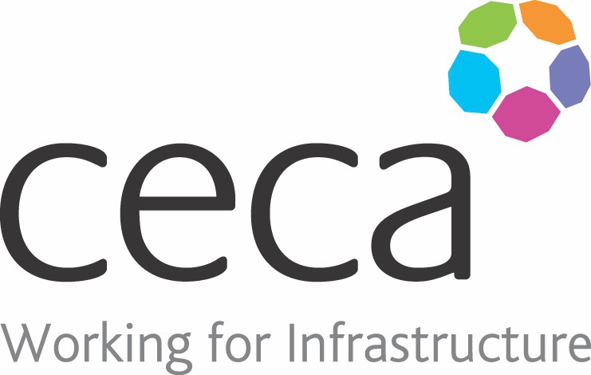
CECA Midlands E Learning

GDPR ESSENTIALS

The General Data Protection Regulation is intended to unify and strengthen data protection for everyone within the European Union.
After concerns were raised about the ‘control’ of personal information within the EU, it was decided that a regulation should be put in place to give control back to the citizens. The government has confirmed that Brexit will not affect the commencement of the GDPR.
GDPR comes into effect on 25th May 2018 but this training programme can be used now and where significant differences exist between the current Data Protection laws and the new GDPR regulations we explain what those differences are.
Our GDPR Essentials Training will teach you about the fundamental requirements needed to comply with the General Data Protection Regulation.
Do you make decisions about collecting, storing, and using people’s personal data? You might be interested in our GDPR Training for Management.

Learning overview:
- Personal data
- Processing data
- Security

Assessment:
This training programme concludes with a 20 question multiple choice test with printable certificate. In addition, brief in-course questionnaires guide the user through the sections of the training, and are designed to reinforce learning and ensure maximum user engagement throughout.

Cost: Registration fee £20 + VAT for full and associate CECA Midlands members.
Award: E learning certificate

Company name: |  | Company contact name:
Company email: |  | Contact tel:
Delegate name: |  | Job title:
Delegate email: |  | Delegate tel:
Accounts Name: |  | Accounts email:

Booking Form – please complete and return to admin@cecamidlands.co.uk one per delegate.
GDPR ESSENTIALS

