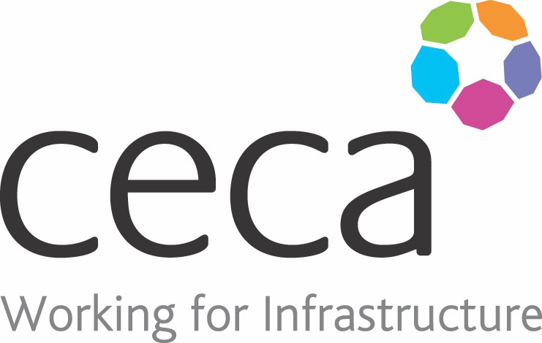
CECA Midlands E Learning

GDPR FOR MANAGERS

Every country in the EU has its own data protection laws. This means that moving data from one country to another can be problematic. To help resolve this issue, the EU created the General Data Protection Regulations, or GDPR, which unifies every country’s data protection laws under a single set of regulations; whilst also extending the control individuals have over their own personal data.
The course is designed for anyone who makes decisions about collecting, storing, and using people’s personal data, and will help you manage staff whose job it is to handle data on a day to day basis.
This GDPR Training for Management course provides an in-depth understanding of the GDPR, covering the core principles of the regulation Save & Exit s, what you need to do to comply with them, and what rights it guarantees for individuals.The GDPR comes into force on 25th May 2018, but it’s crucial that you become compliant before then. This course will help you do just that.
If you do not make decisions about collecting or storing data but are still need to know the GDPR essentials, head over to our GDPR Essentials Training.

Learning overview:
- What is GDPR
- Processing data
- Security
- Accountability
- Individual’s rights

Assessment:
This training programme concludes with a 20 question multiple choice test with printable certificate. In addition, brief in-course questionnaires guide the user through the sections of the training, and are designed to reinforce learning and ensure maximum user engagement throughout.

Cost: Registration fee £20 + VAT for full and associate CECA Midlands members.
Award: E learning certificate

Company name: |  | Company contact name:
Company email: |  | Contact tel:
Delegate name: |  | Job title:
Delegate email: |  | Delegate tel:
Accounts Name: |  | Accounts email:

Booking Form – please complete and return to admin@cecamidlands.co.uk one per delegate.
GDPR FOR MANAGERS

