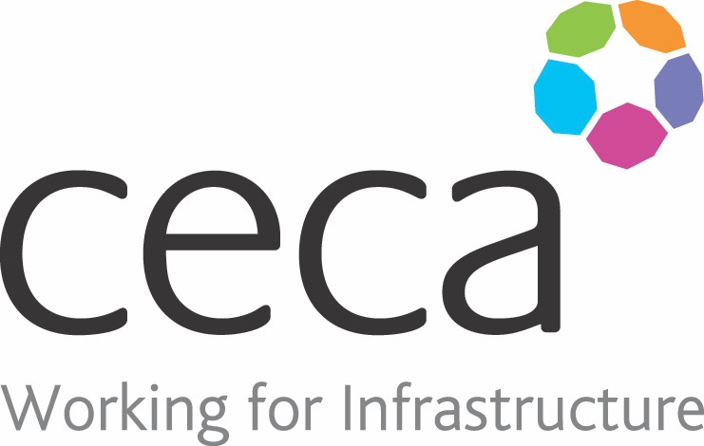
CECA Midlands E Learning

HR COMPLIANCE
Designed for all employees, this course covers some of the key elements of HR and how these can help create an atmosphere of wellbeing in the workplace.
All organisations should strive to have a positive workplace as this gives rise to better productivity and less conflict.
This course is a great help towards achieving this goal as it has been designed to help employees recognise and understand the most common workplace challenges. It then suggests ways to overcome these challenges, including identifying the way we are treated and the way we treat others. It will give an overview on Equality, Diversity & Unconscious Bias, Bullying & Harassment (including Sexual Harassment), Mental Health & Stress Awareness and Conflict Resolution.
If you are looking to offer your staff more in-depth training on particular subjects, each subject within this course is also available as a full, separate course. It is also a perfect course that can be used as part of an induction.

Learning overview:
- Equality & Diversity
- Bullying & Harassment
- Conflict
- Mental Health

Assessment:
This training programme concludes with a 20 question multiple choice test with printable certificate. In addition, brief in-course questionnaires guide the user through the sections of the training, and are designed to reinforce learning and ensure maximum user engagement throughout.

Cost: Registration fee £20 + VAT for full and associate CECA Midlands members.
Award: E learning certificate

Company name: |  | Company contact name:
Company email: |  | Contact tel:
Delegate name: |  | Job title:
Delegate email: |  | Delegate tel:
Accounts Name: |  | Accounts email:

Booking Form – please complete and return to admin@cecamidlands.co.uk one per delegate.
HR COMPLIANCE

