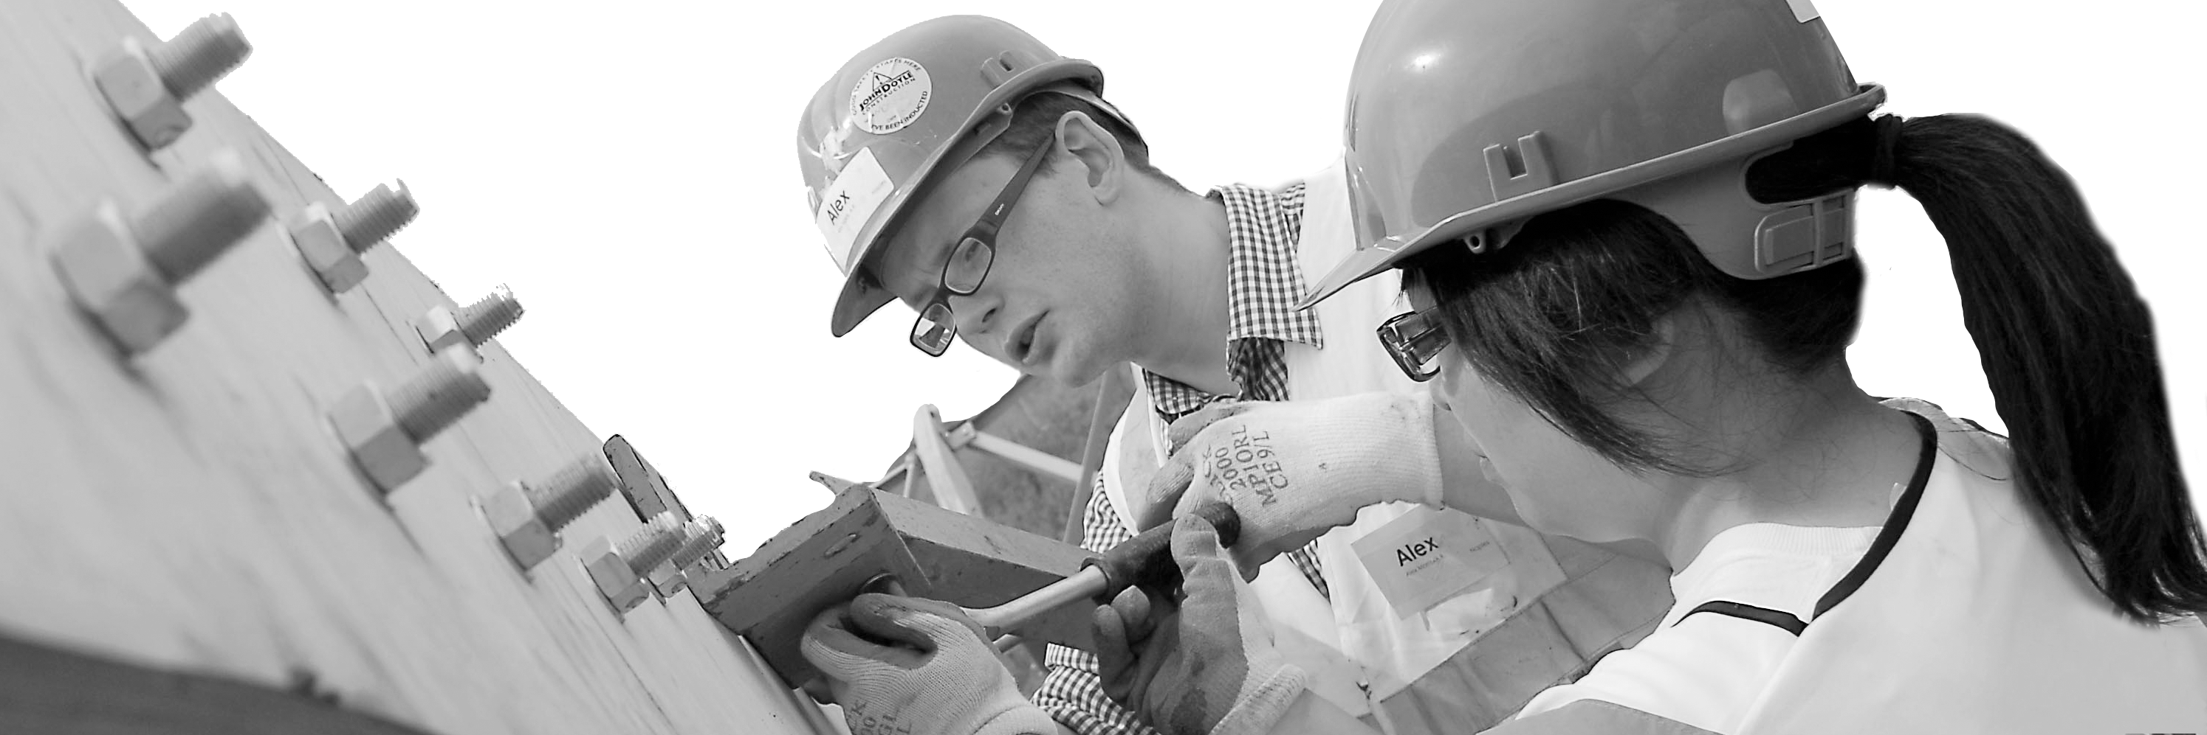
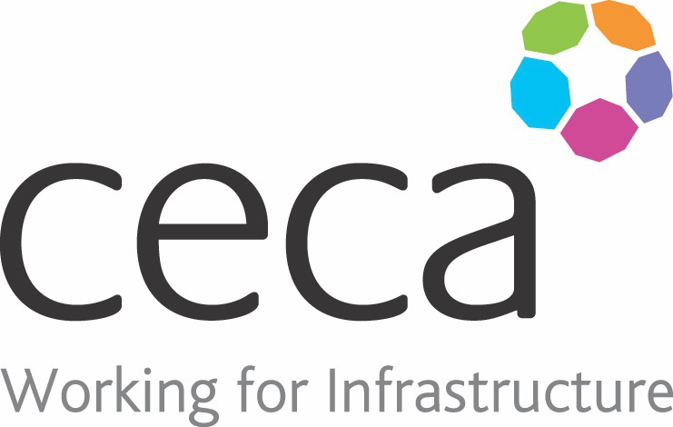
CECA Midlands E Learning

HAND ARM VIBRATION AWARENESS

Regular exposure to vibration can adversely affect your hands and arms.
There were around 635 reports of Vibration White Finger and 260 reports of Carpal Tunnel Syndrome in 2015, which are both contributors to HAVS. Understand your responsibilities as an employee or employer and avoid HAVS with our Hand/Arm Vibration Awareness Training.
Exposure to vibration may not sound dangerous, but the effects can be severely disabling if you ignore the symptoms and carry on without being able to recognise when your exposure exceeds a safe level. This concise and effective training programme will help you to recognise the early warning signs so that something can be done before it’s too late and damage becomes permanent.
This training programme looks at the risks associated with vibration, as well as who’s at risk and what can be done to reduce harmful exposure.
This is core health and safety training for those involved in Construction and Manufacture or using heavy machinery.
People at risk of Hand Arm Vibration Syndrome may also be interested in our Personal Protective Equipment Training.

Learning overview:
- What is hand arm vibration?
- Understanding your responsabilities

Assessment:
This training programme concludes with a 20 question multiple choice test with printable certificate. In addition, brief in-course questionnaires guide the user through the sections of the training, and are designed to reinforce learning and ensure maximum user engagement throughout.

Cost: Registration fee £20 + VAT for full and associate CECA Midlands members.
Award: E learning certificate

Company name: |  | Company contact name:
Company email: |  | Contact tel:
Delegate name: |  | Job title:
Delegate email: |  | Delegate tel:
Accounts Name: |  | Accounts email:

Booking Form – please complete and return to admin@cecamidlands.co.uk one per delegate.
HAND ARM VIBRATION AWARENESS

