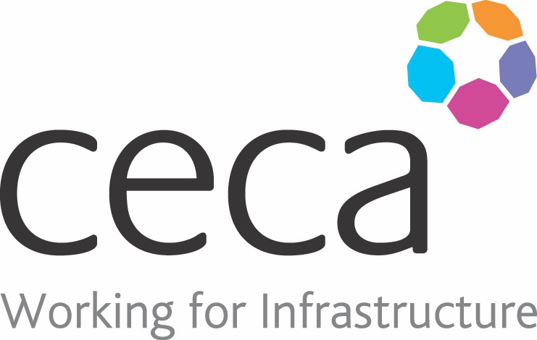
CECA Midlands E Learning

HEALTH & SAFETY ESSENTIALS (GENERAL)

Everyone in your workplace is legally required to have Health and Safety Training and this course provides the perfect introduction to Health and Safety – whether as an induction tool, refresher, or for people changing roles within your organisation.
The course gives a good grounding in general Health and Safety at work, helping employees recognise and avoid risks at work and explaining what to do to minimise illness and reduce workplace accidents.
It looks at responsibilities and legal requirements, hazards and risk, safety signs at work, personal protective equipment and workplace emergency procedures such as fire evacuation and calling the emergency services. It also briefly covers: fire awareness; slips, trips and falls; manual handling; basic DSE; basic COSHH; and electrical safety.
You may also be interested in:
Health and Safety Training for Managers and Supervisors
Health and Safety Training for homeworkers

Learning overview:
- Responsibilities and H&S legal requirements
- Hazards and risks in the workplace
- Safety signs and their importance
- Workplace safety and emergency procedure

Assessment:
This training programme concludes with a 20 question multiple choice test with printable certificate. In addition, brief in-course questionnaires guide the user through the sections of the training, and are designed to reinforce learning and ensure maximum user engagement throughout.

Cost: Registration fee £20 + VAT for full and associate CECA Midlands members.
Award: E learning certificate

Company name: |  | Company contact name:
Company email: |  | Contact tel:
Delegate name: |  | Job title:
Delegate email: |  | Delegate tel:
Accounts Name: |  | Accounts email:

Booking Form – please complete and return to admin@cecamidlands.co.uk one per delegate.
HEALTH & SAFETY AWARENESS (GENERAL)

