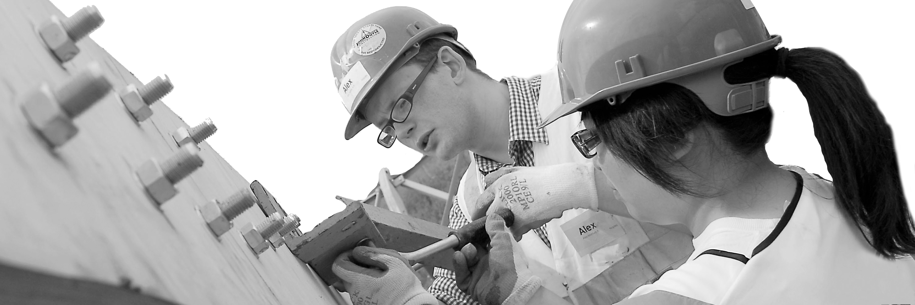
CECA Midlands E Learning

HEALTH & SAFETY FOR HOMEWORKERS
Everyone should have health and safety training, regardless of if they work in a fixed place of work or they work from home. This course is for people who work at home, some, or all of the time. It’s to keep you safe while you’re at work, when your workplace is your own home.
This Health and Safety Training for Homeworkers programme has been designed to provide a good grounding in general health and safety.
It’s for anyone who works at home, whether it’s all of the time or some of the time.
It looks at important areas of safety, INCLUDING (and MUCH MORE):
- Avoiding slips, trips and falls
- Fire safety awareness
- Promoting good lifting technique
- Using electrical equipment safely
- Setting up an office area with comfort and good posture in mind to avoid problems such as bad backs
Other areas covered are home security, work confidentiality, first aid, personal safety and the importance of maintaining a good home-work balance.
Just over 4 million people in the UK class themselves as homeworkers, that amounts to around 14% of the total workforce. Our Health and Safety Training for Homeworkers makes sure that both employees and employers understand their responsibilities.

Learning overview:
- Responsibilities and H&S legal requirements
- Hazards and risks
- Working at home
- Safety and emergency procedures

Assessment:
This training programme concludes with a 20 question multiple choice test with printable certificate. In addition, brief in-course questionnaires guide the user through the sections of the training, and are designed to reinforce learning and ensure maximum user engagement throughout.

Cost: Registration fee £20 + VAT for full and associate CECA Midlands members.
Award: E learning certificate

Company name: |  | Company contact name:
Company email: |  | Contact tel:
Delegate name: |  | Job title:
Delegate email: |  | Delegate tel:
Accounts Name: |  | Accounts email:

Booking Form – please complete and return to admin@cecamidlands.co.uk one per delegate.
HEALTH & SAFETY FOR HOME WORKERS

