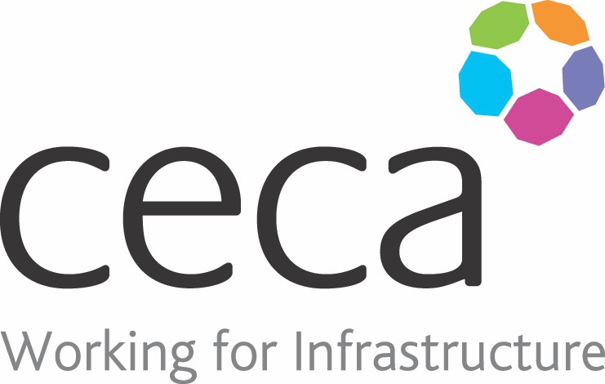
CECA Midlands E Learning

HEALTH & SAFETY FOR MANAGERS & SUPERVISORS
This programme has been written for employers and managers who have a responsibility for the health and safety of all personnel within their organisation.
The course is a concise and easy-to-follow guide, which leads health and safety managers through the necessary steps to health and safety at work and provides information on the different laws and legislation which apply.
​It is a core programme for people who are new to health and safety and want to know what they have to do, but also excellent as a check-list for all health and safety managers, no matter how experienced.
​Health and Safety within an organisation is not only about compliance – effective health and safety has many benefits, including safer, happier and healthier employees; a better company reputation; and a lower accident rate. It also helps reduce absences from work and helps to avoid serious accidents at work, so it’s important to get it right.

Learning overview:
- The 10 steps
- Legislation
- Health & safety myths

Assessment:
This training programme concludes with a 20 question multiple choice test with printable certificate. In addition, brief in-course questionnaires guide the user through the sections of the training, and are designed to reinforce learning and ensure maximum user engagement throughout.

Cost: Registration fee £20 + VAT for full and associate CECA Midlands members.
Award: E learning certificate

Company name: |  | Company contact name:
Company email: |  | Contact tel:
Delegate name: |  | Job title:
Delegate email: |  | Delegate tel:
Accounts Name: |  | Accounts email:

Booking Form – please complete and return to admin@cecamidlands.co.uk one per delegate.
HEALTH & SAFETY FOR MANAGERS & SUPERVISORS

