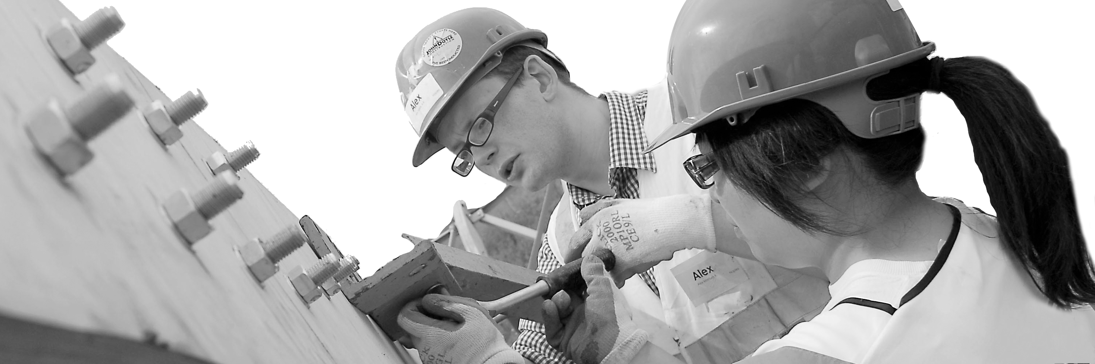
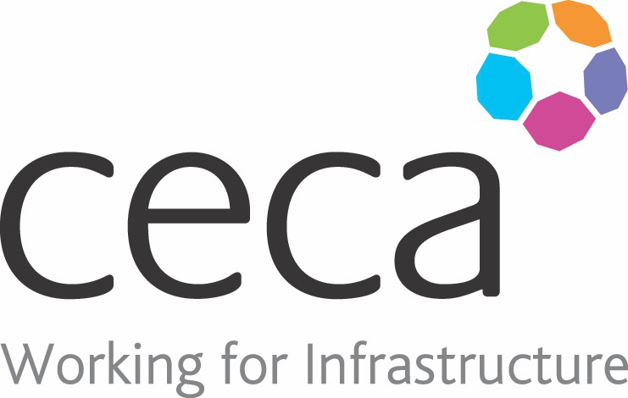
CECA Midlands E Learning

LIFTING OPERATIONS (LOLER) AWARENESS
This Lifting Operations and Lifting Equipment Regulations 1998 (LOLER) training course aims to reduce the chances of any accidents or incidents occurring during any lifting operations in the workplace. The course covers the regulations thoroughly, to give you an understanding of how to work towards compliance.
In the U.K alone, there have been 61 recorded accidents involving tower cranes, resulting in 25 injuries and 9 deaths.
The Lifting Operations and Lifting Equipment Regulations 1998 provide guidelines to show you how lifting operations should take place in the safest possible way.
These lifting operations require adequate planning, safe systems of work, constant supervision and thorough examination.
The aim of this LOLER Training is to reduce the chances of these figures growing any larger. The guidelines provide safe methods of work, and we explain in detail how you implement these guidelines into everyday work. It will take you through the fundamental requirements needed in order to work towards compliance with the Lifting Operations and Lifting Equipment Regulations 1998.
You may also be interested in our PUWER Training.

Learning overview:
- What is LOLER
- Selecting the correct equipment
- Location of equipment
- Plant lifting operations
- Maintenance of lifting equipment

Assessment:
This training programme concludes with a 20 question multiple choice test with printable certificate. In addition, brief in-course questionnaires guide the user through the sections of the training, and are designed to reinforce learning and ensure maximum user engagement throughout.

Cost: Registration fee £20 + VAT for full and associate CECA Midlands members.
Award: E learning certificate

Company name: |  | Company contact name:
Company email: |  | Contact tel:
Delegate name: |  | Job title:
Delegate email: |  | Delegate tel:
Accounts Name: |  | Accounts email:

Booking Form – please complete and return to admin@cecamidlands.co.uk one per delegate.
LIFTING OPERATIONS (LOLER) AWARENESS

