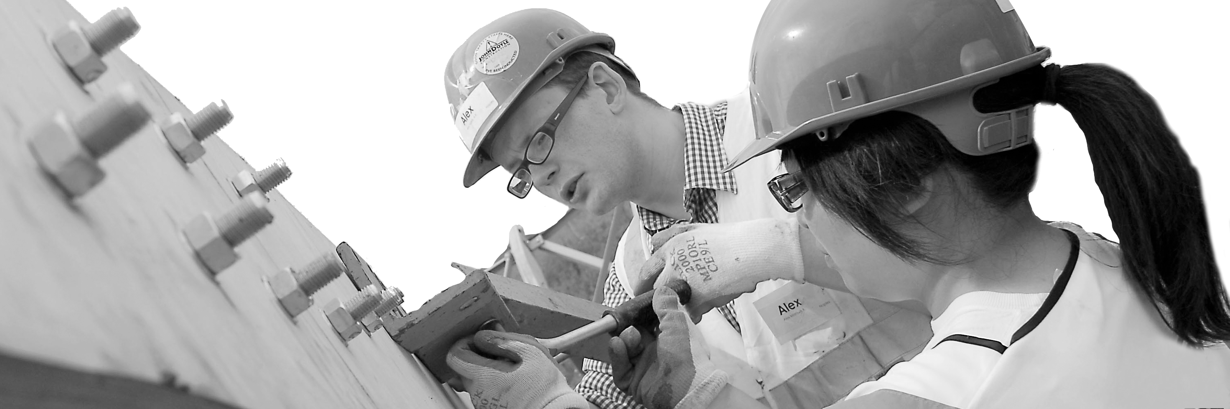
CECA Midlands E Learning

LADDER SAFETY
This Ladder Safety training is your go-to course to help reduce the risk of ladder-related injuries and increase your knowledge and skills. It includes how to select, setup, and use a ladder correctly, as well as conduct pre-checks. It’s CPD accredited and provides printable certificates upon course completion.
Falling from a height is incredibly common and incredibly dangerous, and at least a third of all fall injuries involve ladders. This makes them one of the largest causes of accidents and injuries – both in the workplace and at home. Training is therefore essential.
You don’t need to be formally qualified to use a ladder, but you do have to be competent. This course has been created to help strengthen the necessary skills and knowledge you need to use ladders safely.
It is split into four short sections, Ladder Selection, Ladder Pre-Check, Ladder Setup and Ladder Use.
This Ladder Safety Training can be used in conjunction with our Working at Height Training.

Learning overview:
- Ladder selection
- Ladder pre check
- Ladder set up
- Ladder use

Assessment:
This training programme concludes with a 20 question multiple choice test with printable certificate. In addition, brief in-course questionnaires guide the user through the sections of the training, and are designed to reinforce learning and ensure maximum user engagement throughout.

Cost: Registration fee £20 + VAT for full and associate CECA Midlands members.
Award: E learning certificate

Company name: |  | Company contact name:
Company email: |  | Contact tel:
Delegate name: |  | Job title:
Delegate email: |  | Delegate tel:
Accounts Name: |  | Accounts email:

Booking Form – please complete and return to admin@cecamidlands.co.uk one per delegate.
LADDER SAFETY

