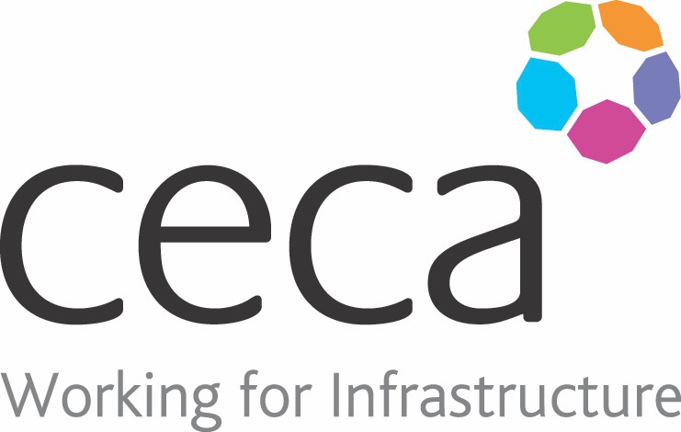
CECA Midlands E Learning

LEGIONELLA AWARENESS
This training programme increases awareness of the dangers of legionella bacteria and highlights the importance of regular maintenance and monitoring of systems where they may be found.
Designed to help everyone understand the risks of exposure to legionella bacteria, this course is particularly useful for those who are responsible for protecting an organisation from this kind of bacterial contamination; particularly people who manage, control or monitor the risk of exposure (as well as those responsible for record keeping.)
The course looks at what legionella bacteria are and where they can be found, as well as how legionella spreads and how these bacteria can affect health – concentrating particularly on Legionnaires’ disease and the symptoms to look out for.

Learning overview:
- Legionella bacteria
- Preventing an outbreak

Assessment:
This training programme concludes with a 20 question multiple choice test with printable certificate. In addition, brief in-course questionnaires guide the user through the sections of the training, and are designed to reinforce learning and ensure maximum user engagement throughout.

Cost: Registration fee £20 + VAT for full and associate CECA Midlands members.
Award: E learning certificate

Company name: |  | Company contact name:
Company email: |  | Contact tel:
Delegate name: |  | Job title:
Delegate email: |  | Delegate tel:
Accounts Name: |  | Accounts email:

Booking Form – please complete and return to admin@cecamidlands.co.uk one per delegate.
LEGIONELLA AWARENESS

