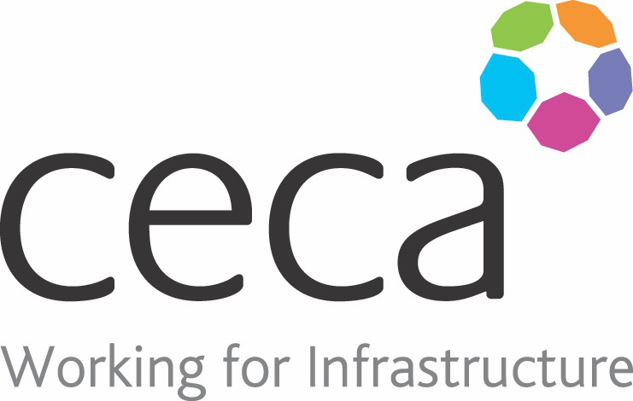
CECA Midlands E Learning

LONE WORKER IN THE WORKPLACE
This Lone Working Training is an essential e-learning course that helps Lone Workers who spend time on their own but within a workplace (for instance security personnel, cleaners or lone shop staff) to increase their safety every day by planning ahead, recognising aggression and learning how to use diffusion tactics.
Although it’s hard to believe, around 46% of workers in the UK consider themselves to be ‘lone workers’ and they come from various industries, such as housing, social & health, homeworkers, transport & logistics, construction, retail and out of hours work.
Lone working is completely legal, however employers have a legal obligation to consider risks to health and safety. We believe our Lone Workers Training to be the perfect solution.
This health and safety training programme has been designed to help increase personal safety during a working day – specifically those working alone or away from colleagues.
It also applies to those whose job requires them to receive visitors, members of the public, customers or patients – in fact anyone they may not know. Although personal safety at work is something that concerns everyone, lone workers are more vulnerable and at greater risk of violence and aggression.
This course will introduce the topic of personal safety; looking at increasing observation and awareness of other people’s behaviour and making sure you have strategies to avoid threatening situations.
If your job requires you to work away from a fixed workplace, our Lone Working OUT OF the Workplace training may be more useful to you.

Learning overview:
- What is personal safety?
- Practical planning
- Staying in control in difficult situations
- Working alone

Assessment:
This training programme concludes with a 20 question multiple choice test with printable certificate. In addition, brief in-course questionnaires guide the user through the sections of the training, and are designed to reinforce learning and ensure maximum user engagement throughout.

Cost: Registration fee £20 + VAT for full and associate CECA Midlands members.
Award: E learning certificate

Booking Form – please complete and return to admin@cecamidlands.co.uk one per delegate.
LONE WORKER IN THE WORKPLACE

Company name: |  | Company contact name:
Company email: |  | Contact tel:
Delegate name: |  | Job title:
Delegate email: |  | Delegate tel:
Accounts Name: |  | Accounts email:

