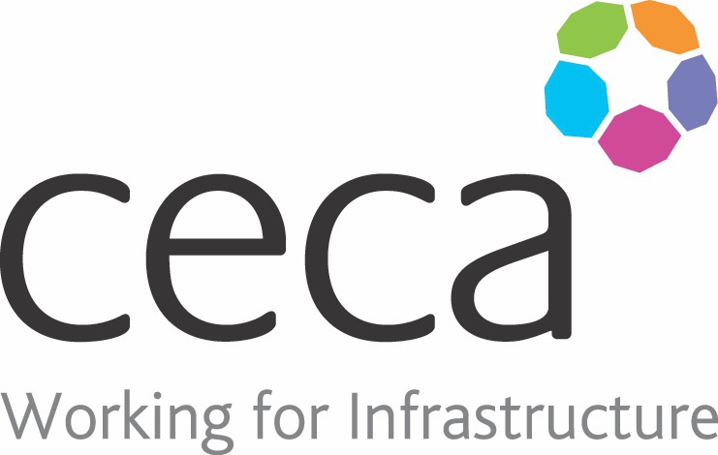
CECA Midlands E Learning

LONE WORKING OUT OF THE WORKPLACE
This health and safety programme has been designed to help increase personal safety during a working day. It has particularly been designed for people who work alone, away from a fixed workplace and away from co-workers.
Although personal safety at work is something that concerns everyone, lone workers are more vulnerable and at greater risk of violence and aggression.
This course will give you a good grounding in appropriate measures to ensure your personal safety: It looks at increasing observation and awareness of both your surroundings and the behaviour of those around you; building preparation into your daily routine and providing strategies to avoid threatening situations. Lone Working OUT of the Workplace also looks at what to do if things go wrong, and covers how to effectively use buddy and tracing systems.

Learning overview:
- What is personal safety?
- Practical planning
- Staying in control
- Buddy systems
- Personal safety risk assessment

Assessment:
This training programme concludes with a 20 question multiple choice test with printable certificate. In addition, brief in-course questionnaires guide the user through the sections of the training, and are designed to reinforce learning and ensure maximum user engagement throughout.

Cost: Registration fee £20 + VAT for full and associate CECA Midlands members.
Award: E learning certificate

Company name: |  | Company contact name:
Company email: |  | Contact tel:
Delegate name: |  | Job title:
Delegate email: |  | Delegate tel:
Accounts Name: |  | Accounts email:

Booking Form – please complete and return to admin@cecamidlands.co.uk one per delegate.
LONE WORKING OUT OF THE WORKPLACE

