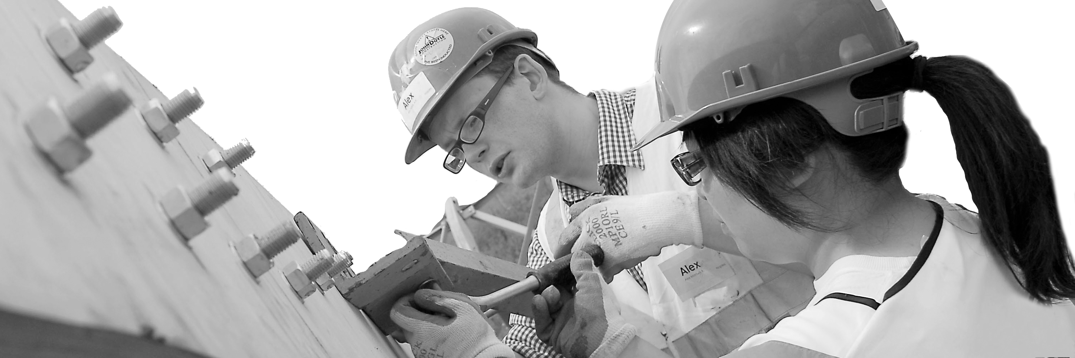
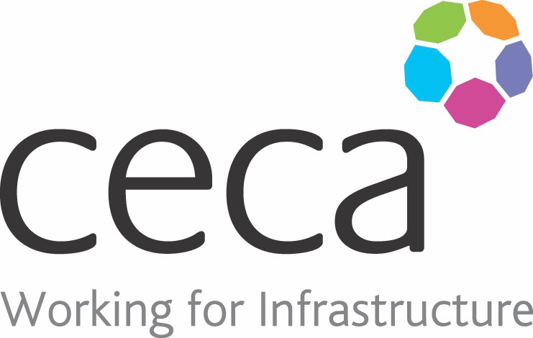
CECA Midlands E Learning

MANAGING ANXIETY
This Managing Anxiety Training course provides ideas and techniques to help people to manage their anxiety, including stomach-breathing techniques, strengthening resilience and forms that help people to highlight how they felt and behaved during an anxiety-provoking event. CBT, or cognitive behavioural therapy, can play a key part in helping people better manage anxious thoughts.
Recognised by the NHS, here is how they describe the process: “Cognitive behavioural therapy” is a talking therapy that can help you manage your problems by changing the way you think and behave.
It's most commonly used to treat anxiety and depression, but can be useful for other mental and physical health problems”. When users complete our course, we hope that they feel more confident in addressing uncomfortable or upsetting situations, so they can lessen the impact they have on them.

Learning overview:
- Anxiety and CBT
- Help with anxiety

Assessment:
This training programme concludes with a 20 question multiple choice test with printable certificate. In addition, brief in-course questionnaires guide the user through the sections of the training, and are designed to reinforce learning and ensure maximum user engagement throughout.

Cost: Registration fee £20 + VAT for full and associate CECA Midlands members.
Award: E learning certificate

Company name: |  | Company contact name:
Company email: |  | Contact tel:
Delegate name: |  | Job title:
Delegate email: |  | Delegate tel:
Accounts Name: |  | Accounts email:

Booking Form – please complete and return to admin@cecamidlands.co.uk one per delegate.
MANAGING ANXIETY

