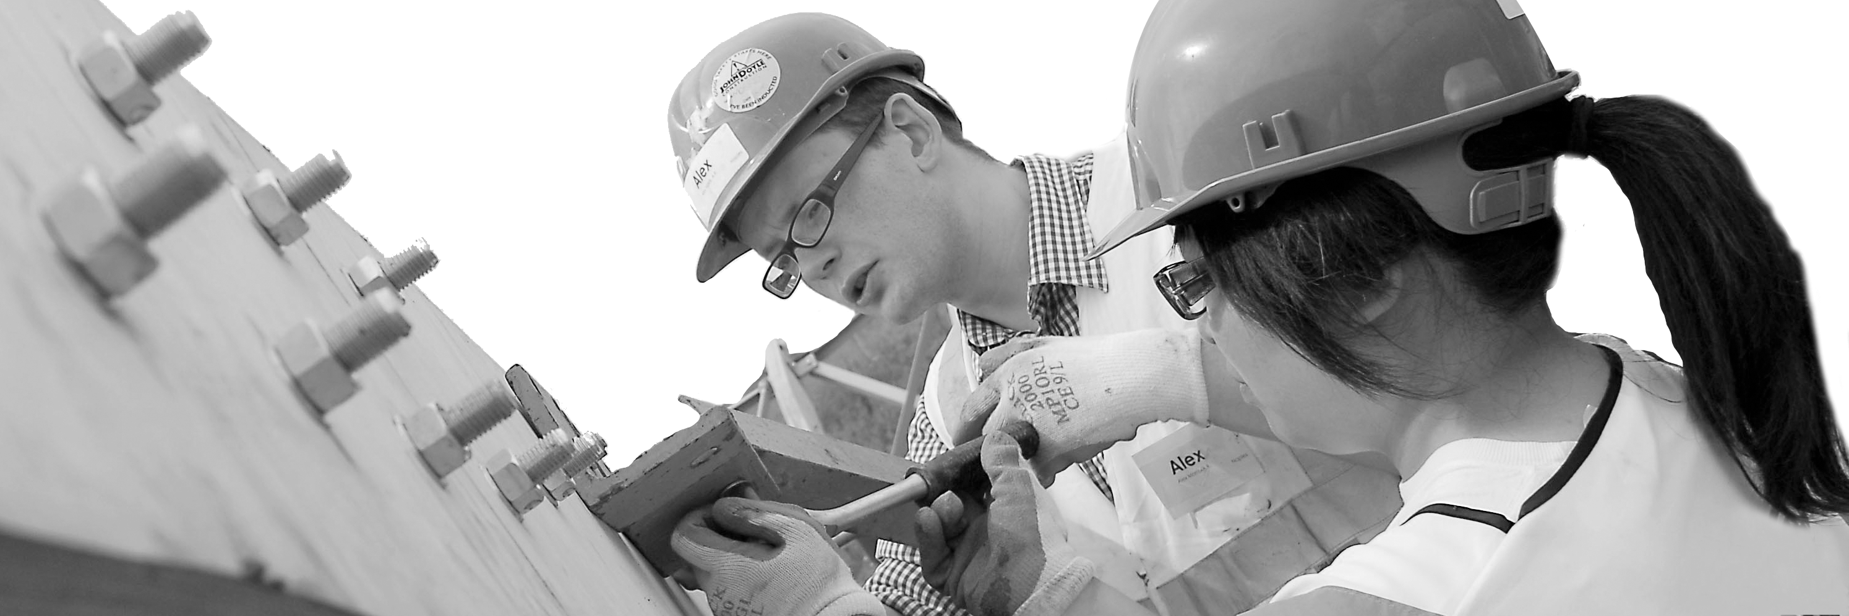
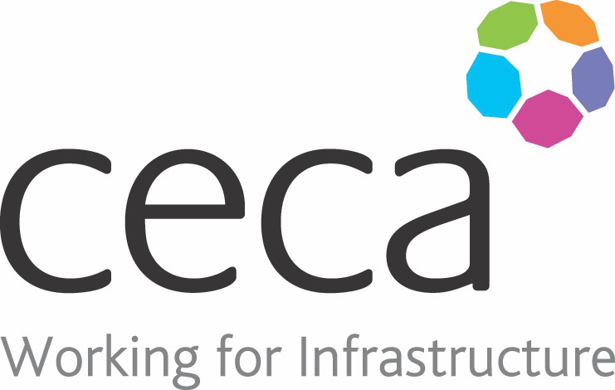
CECA Midlands E Learning

MANUAL HANDLING PRINCIPLES
This online Manual Handling training teaches you all you need to know about safe lifting, moving and handling, including lifting techniques, LITE, and why Manual Handling training is so important to your everyday health – more specifically, comprehensive guidance on how to maintain a healthy back.

Learning overview:
- Your back during manual handling

- Daily tasks
- LITE assessment
- Techniques

Assessment:
This training programme concludes with a 20 question multiple choice test with printable certificate. In addition, brief in-course questionnaires guide the user through the sections of the training, and are designed to reinforce learning and ensure maximum user engagement throughout.

Cost: Registration fee £20 + VAT for full and associate CECA Midlands members.
Award: E learning certificate

Company name: |  | Company contact name:
Company email: |  | Contact tel:
Delegate name: |  | Job title:
Delegate email: |  | Delegate tel:
Accounts Name: |  | Accounts email:

Booking Form – please complete and return to admin@cecamidlands.co.uk one per delegate.
MANUAL HANDLING PRINCIPLES

